***Elements A-L: Final Document***

WWHS PLTW

EDD 2017-18

Archer Hasbany

Michael Kavas

HasKav



Table of Contents

Element A – Problem Identification and Justification 3

Element B – Identification and Analysis of Prior Solution Attempts 9

Element C – Presentation and Justification of Design Requirements 20

Element D – Design Concepts Generation, Analysis, and Selection 27

Element E – Application of STEM Principles and Practices 31

Element F – Consideration of Design Viability 36

Element G – Creation of a Testable Prototype 42

Element H – Prototype Testing and Data Collection Plan 47

Element I – Data Results and Testing Analysis 49

Element J – Documentation of External Evaluation 51

Element K – Designer Reflection on the Process 54

Element L – Presentation of the Designer’s Recommendations 59

Final Notes 64

# Element A – Problem Identification and Justification

Problem Background

Throughout the 3 years I have spent at Woodrow Wilson high school, I have always scanned for problems that I thought I could solve, as I knew someday I would be sitting here trying to figure out what I wanted to do in this class. After years of consideration of feasibility and impact on the school, I decided that the attendance system was what I was going to look for a solution to.

In its current state, the Woodrow attendance system is completely manual, and after 3 years of receiving false absences and arguing with the attendance office, I am determined to make this process easier for students, teachers, and parents. In every single class I’ve ever had at Woodrow, the teacher has to take some time out of their day to take roll for their classes. Now while this may only be a minute or so per day, the long-term effect that this has on class efficiency is where the problem truly lies. It has taken me 3 years to determine why classes seem to pass so quickly, and I have realized that it is due to the fact that the first few minutes of every class is completely wasted by attendance or general set up. Now while I cannot fix the inefficiency of teachers, I can make the attendance system completely automated and remove that responsibility from them. Every single student is affected by this poorly designed system, and it is unfair that any class time at all is taken from them by roll call. In professional labs and corporations, it would be unreasonable for a manager to take roll at the beginning of the day, so why is it reasonable for a school with less time to spare?

As well as suffering from a poor attendance system, Woodrow has an even less sensible tardy system. If a student does not show up within 10 minutes after the final bell, the teacher must mark the student as absent. If the teacher takes roll immediately as class starts, they then have to take it again 10 minutes later to address any tardy students, as well as mark down any students that enter within that 10-minute period. Worse than that, if a student is late, they must go to the “intervention center,” which is on another floor entirely, to get a tardy pass. Not only does being tardy waste the teachers time, it destroys the already short class period for the student. I was simply blown away by the sheer insensibility of this system when I heard about it, so I am extremely determined to find a solution to it. If students were to just “scan” in or out every time they entered or left a class room, attendance, tardiness, and roll call would all be combined and executed by a system that requires no teacher interaction. This would completely dissolve the ridiculous tardy pass system, and make absences and tardiness far easier to keep track of. In a school with as many opportunities as Woodrow, it is a shame that any class time at all is wasted by something as simple as attendance.

Problem Justification

32 teachers filled out a survey that I created asking the following questions:

• Do you think the current attendance system is effective?

• Do you think students could be personally responsible for signing in/out?

• Would you be interested in an automated attendance system?

Out of the 32 submissions, 66% said that the attendance system was a problem, and 100% stated that they would like to see some form of automated attendance system. It can be obviously inferred that a teacher would want something that makes their life easier, but to what degree this would actually help the school is what I need to determine. Teachers are the ones who are directly affected by the inefficiency of the attendance system, but the effect that has on the students is just as considerable. The time wasted when the teacher is there less than when a sub takes attendance.

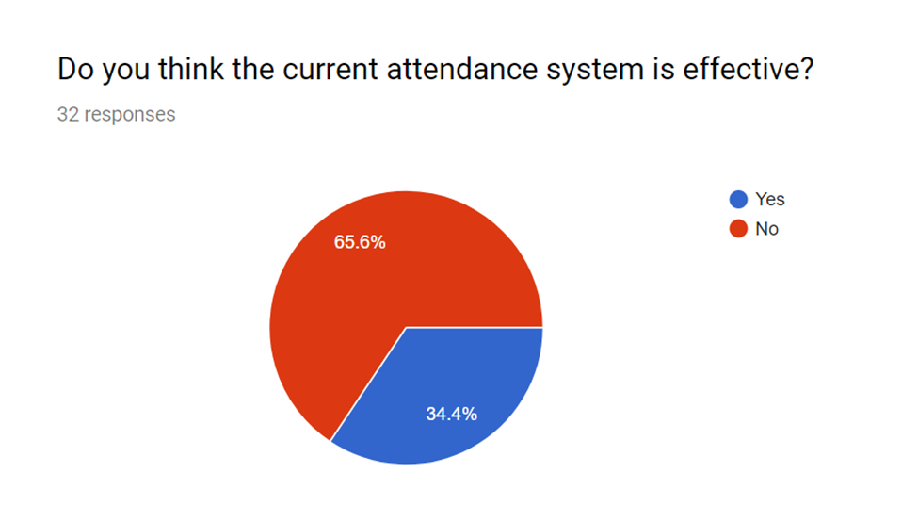

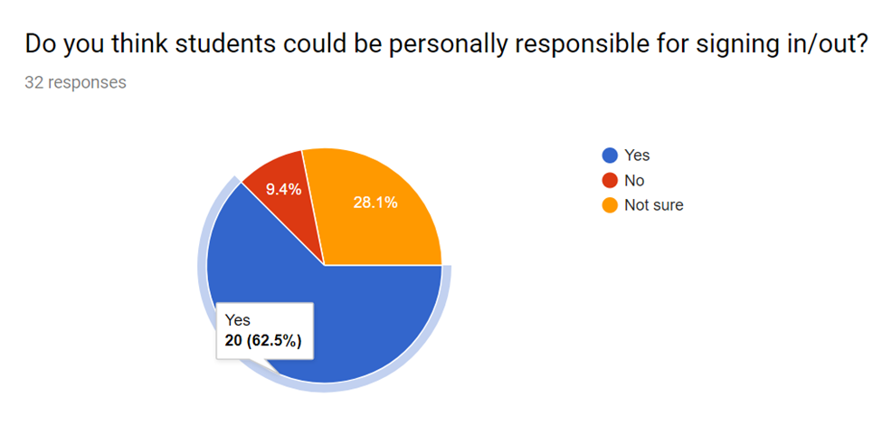

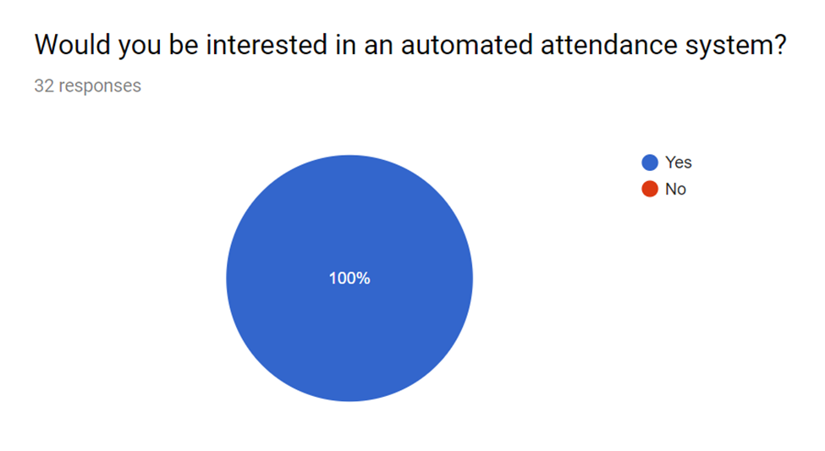

Problem Statement

The current attendance system at Woodrow Wilson High School wastes time and is inaccurate. Out of 32 teachers that took a survey in 2017, 66% stated that that the current system Is ineffective, and 100% stated that they would like to see some sort of automated attendance system.

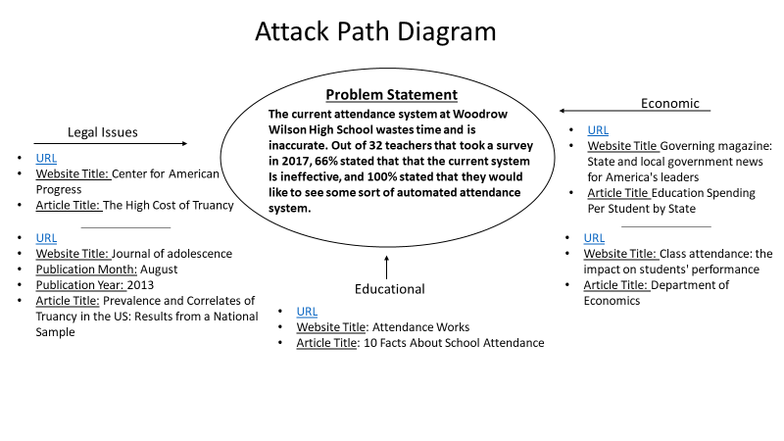Attack Path

Relevant Associations

[Creatrix Campus](https://www.creatrixcampus.com/about-us)

* Abbrev - CC
* Address - 7801 Broadway Ste 205

San Antonio, Texas, 78209

* Phone - 210 417 4073
* Creatrix Campus is a large-scale automation tool intended for higher education scenarios. CC is a wholistic approach to automation, as it claims to improve discipline, assignment tracking, as well as attendance. They offer fully cloud based attendance solutions, using RFID or Biometric scanners to log hours. Although they aim to solve a similar problem, their system assumes that your university has no current system in place and is far too expensive for quick and affordable installation.

[MyAttendaceTracker](https://www.myattendancetracker.com/)

* Abbrev - MyAT
* Address - N/A – Online software made by one guy
* Phone - N/A
* Contact - [sign up page](https://www.myattendancetracker.com/contact)
* MyAT is a completely software based attendance tracker, and is tailored more for a small amount of people. While it does somewhat automate the process, it still requires manual entry from the instructor, therefore not making it any more efficient than the current system. It also does not integrate with any current attendance databases.

[JollyTech](http://www.jollytech.com/software-and-systems/student-attendance-system.php)

* Abbrev – N/A
* Address - 1510 Fashion Island Blvd, Ste 102 San Mateo, CA 94404
* Phone – 650 594 5955
* JollyTech offers a solution to this problem, at the expense of high cost and extensive set up. They offer a range of attendance solutions such as RFID, Biometric scanning and PIN entry. While it does keep track of student attendance, it does not integrate with any current attendance system.

[KiNVO](https://kinvolved.com/features)

* This product is a mobile and web app that focuses on student attendance and productivity primarily. Through messaging, the system keeps track of student actions and attendance. This is another method to consider, although it requires high-level coding.

Skyward Student Information System

* 800-236-7274
* 104 Decker Court, Suite 250 Irving TX 75062 United States
* This system has an entire suite of software for classroom and school management, including attendance. The system uses a PIN-Input system for recording student attendance, another method we could consider.

# Element B – Identification and Analysis of Prior Solution Attempts

We found our similar solutions through Google, and we found our patents from Google Patents. After reading through the solutions/patents, we found that many of them approach the issue of attendance from a professional standpoint, rather than focusing on schools. The majority of them used RFID’s or a barcode scanner to log attendance, instead of biometrics. This may work at a smaller institution, but at large schools such as Woodrow, it will likely be insecure. While most solutions didn’t exactly solve the problem, they included elements that could be useful to our solution.

Patent Search

1. Institutional student tracking system (TRAX)
   1. Grybas, D. (2002). U.S. Patent No. US20020178038A1. Washington, DC: U.S. Patent and Trademark Office.
   2. US20020178038A1
   3. This patent describes an “improved institutional student tracking system” that consists of software divided into several modules that control different aspects of student record management. The proposed software can send information reports and be accessed over the internet.
   4. 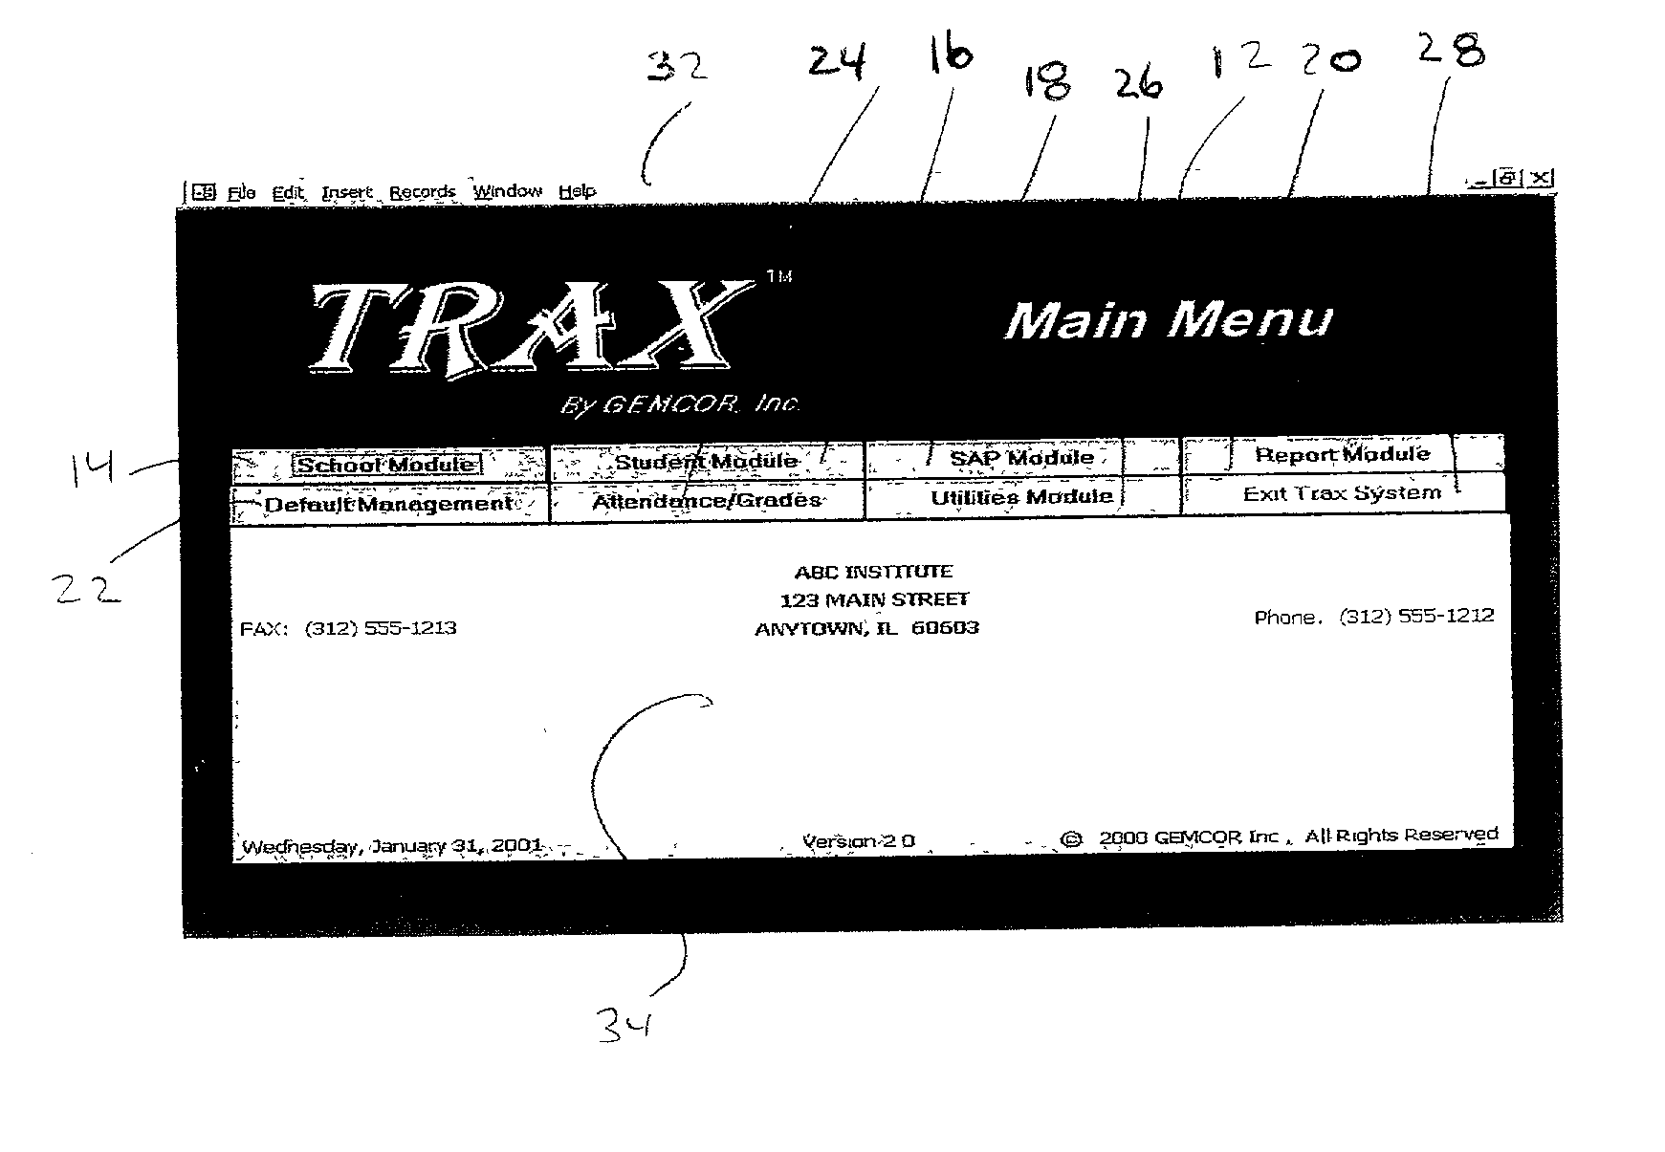Overall, this software tracks attendance very efficiently. It has modules for students, reports, schools, academics, and management. However, it was created in 2002, and the interface is outdated. Additionally, system controls more information than just attendance, which extends beyond what we need to accomplish. The interface, while outdated, can provide a good model of what we may attempt to create.
2. Wireless LAN scholastic tracking system
   1. Schenker, A. J., Fluharty, M., & Swartz, J. (2003). U.S. Patent No. US6633223B1. Washington, DC: U.S. Patent and Trademark Office.
   2. US6633223B1
   3. This product tracks student attendance, movement, inventory, and educational progress. The students use ID cards for recognition in the system.
   4. While this system tracks attendance, it also tracks less important information such as what inventory is in use by students. The ID card system is somewhat secure and efficient, but still allows for people logging their friends into the system. We can learn from the use of assigning identities to ID cards/a database.

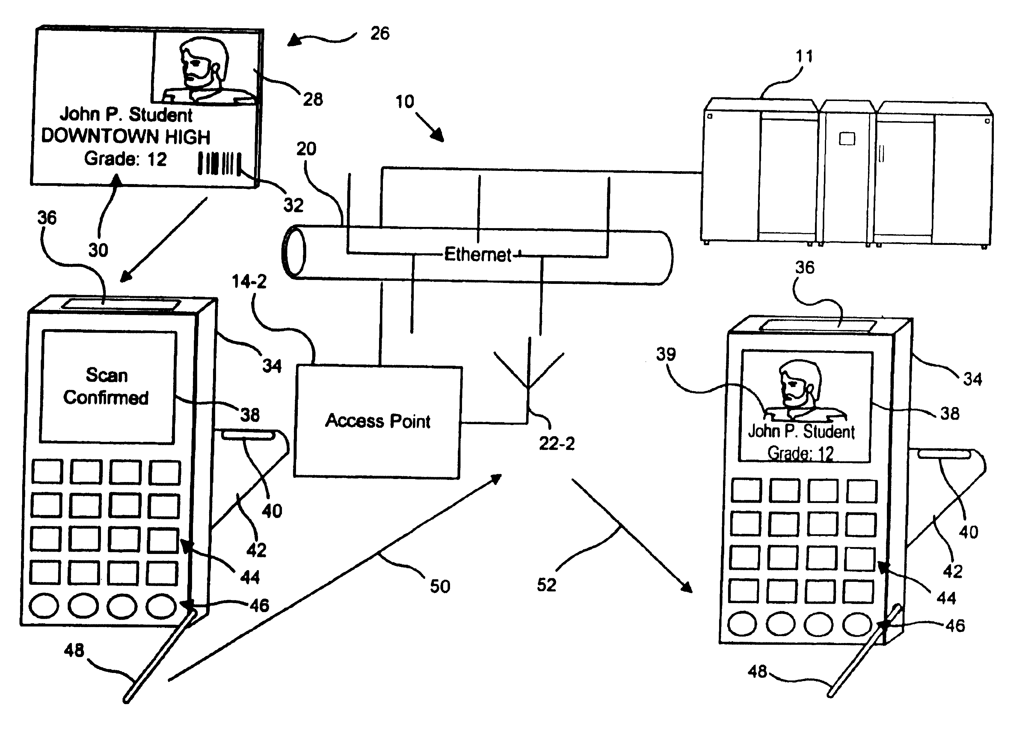

1. Modular school computer system and method
   1. Striemer, B. L. (2003). U.S. Patent No. US20030197607A1. Washington, DC: U.S. Patent and Trademark Office.
   2. US20030197607A1
   3. This product equips a school with multiple “hubs” that track students and teachers using RFID. The system makes sure that people are not only at the school, but also where they are supposed to be.
   4. This product tracks attendance in a unique way, and allows many different devices to be used to track people. However, using proximity can be an issue in a school environment. Students change location many times a day, and often go to the bathroom of other areas in the middle of class. Additionally, you can leave your ID in a room to cheat the system.

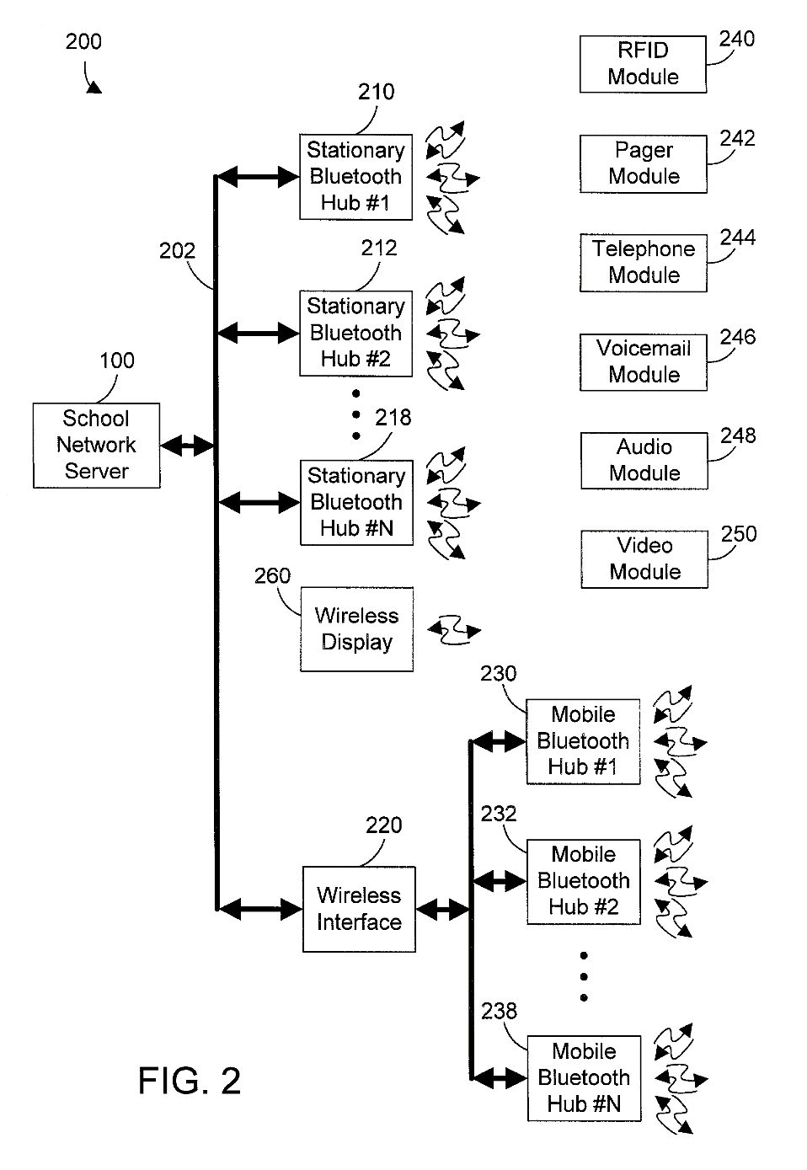

1. Notification and response system with attendance tracking features
   1. Rodkey, R. S., Rodkey, J. F., Jr., Hickey, D. L., & Ross, D. L. (2010). U.S. Patent No. US7684548B1. Washington, DC: U.S. Patent and Trademark Office.
   2. US7684548B1
   3. This system uses devices in both the hands of administrators (teachers) and students. An administrator uses their device to send a message to all linked student devices, and students use their devices to respond to the message, filling out a survey of information regarding their identity, attendance, contact information, etc.
   4. This product does not solve any major portion of our issue. While attendance tracking is moved from paper to a digital platform, there is still significant user interaction required from both parties compared to a situation where ID’s or biometrics were used. Additionally, identities are not secured as anyone with a friend’s device can input their information falsely.

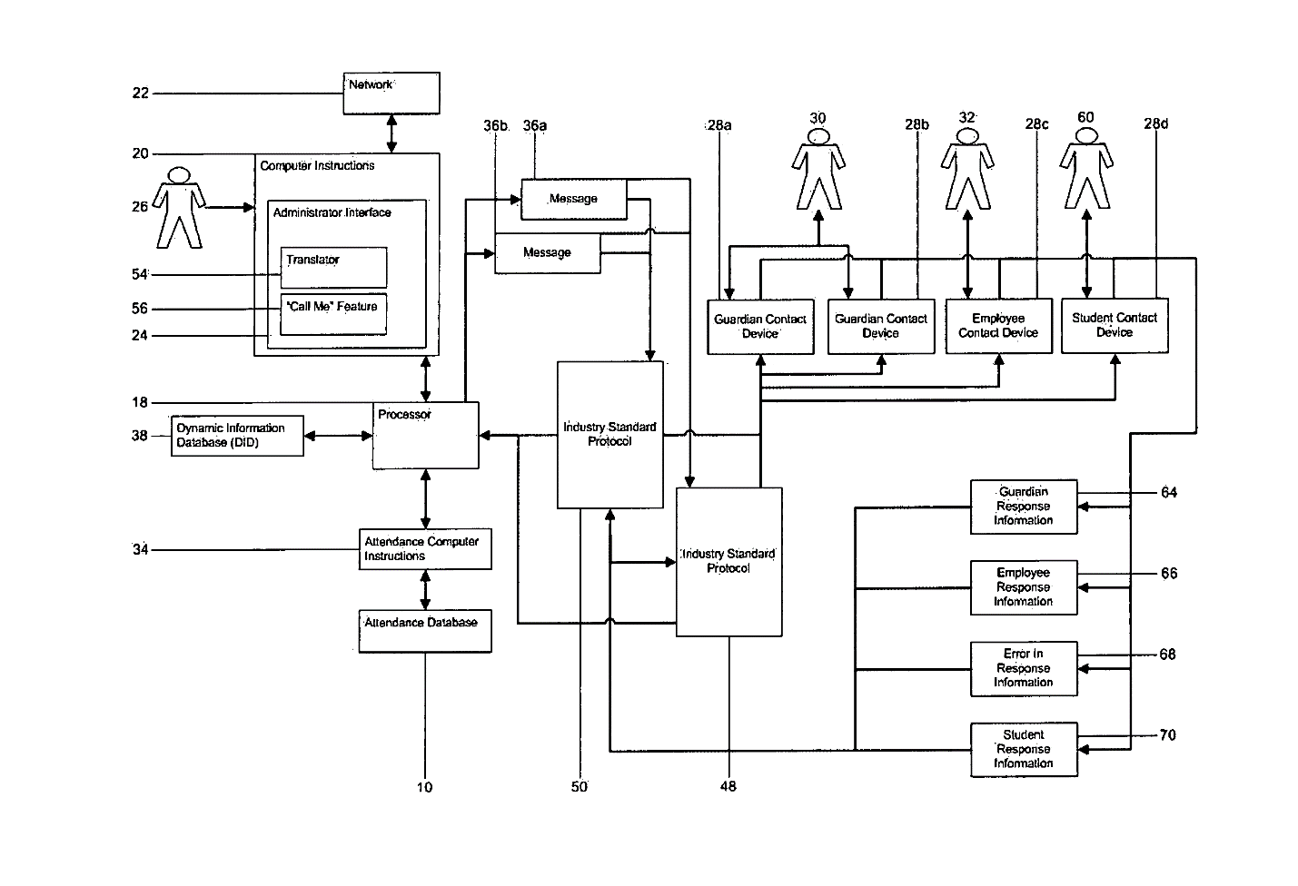

1. Attendance tracking system
   1. Dobson, M., Ahlers, D., & DiDario, B. (2006). U.S. Patent No. US20060035205A1. Washington, DC: U.S. Patent and Trademark Office.
   2. US20060035205A1
   3. This system uses identification tags to wirelessly detect attendees (students) when they enter a room. After detecting all current students, the system generates an attendance report that the supervisor (teacher) verifies. It is built to be useful in any environment where attendance tracking is required, but is particularly suited for schools.
   4. This system tracks attendance in a clean and mostly-effortless manner. However, attendance still needs to be verified by the teacher, which may seem unavoidable, but is a major component of our issue that should be fixed, not worked around. Additionally, ID’s are prone to being used falsely, whereas biometrics are not.

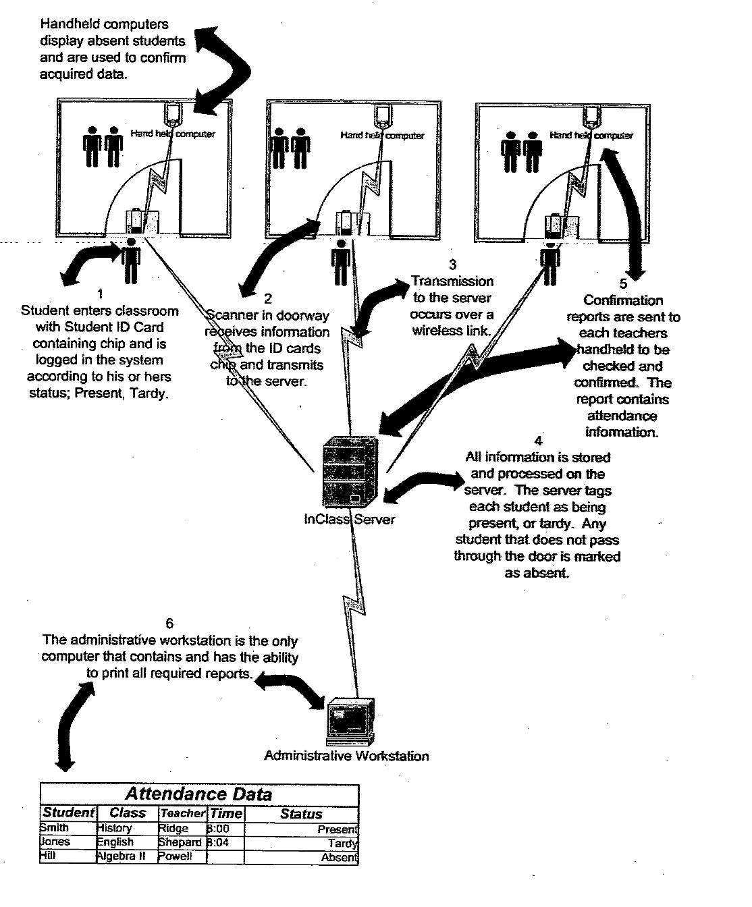

Similar Solutions

1. Creatrix Campus – Student Tracking Software
   1. <https://www.creatrixcampus.com/student-tracking-software>
   2. This product is a campus management system that can be implemented in high schools. It offers many features, including automatic attendance management. Messages and alerts are sent to teachers and parents for attendance concerns.
   3. This product streamlines the attendance tracking procedure, accomplishing the task we have set out to solve. It is a functional and high-quality program.
   4. The software includes many other, irrelevant modules that create over complication and overpricing. While they are useful, schools already take care of them and they are not the focus of our issue.

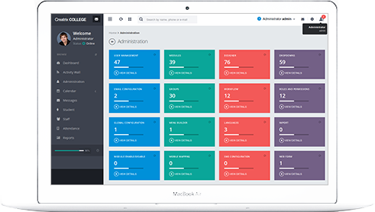

1. Skyward Student Information System
   1. <https://www.skyward.com/k-12/student-information-system>
   2. This system has an entire suite of software for classroom and school management, including attendance. The system uses a PIN entry system for recording student attendance.
   3. Skyward SIS has multiple paperless tools for tracking and analyzing attendance, which solves our problem. It includes many features, such as custom seating charts and support for multiple devices.
   4. Again, this product is too large in scope, and offers multiple additional products that are not necessary. These cause the product to be overpriced and complicated.

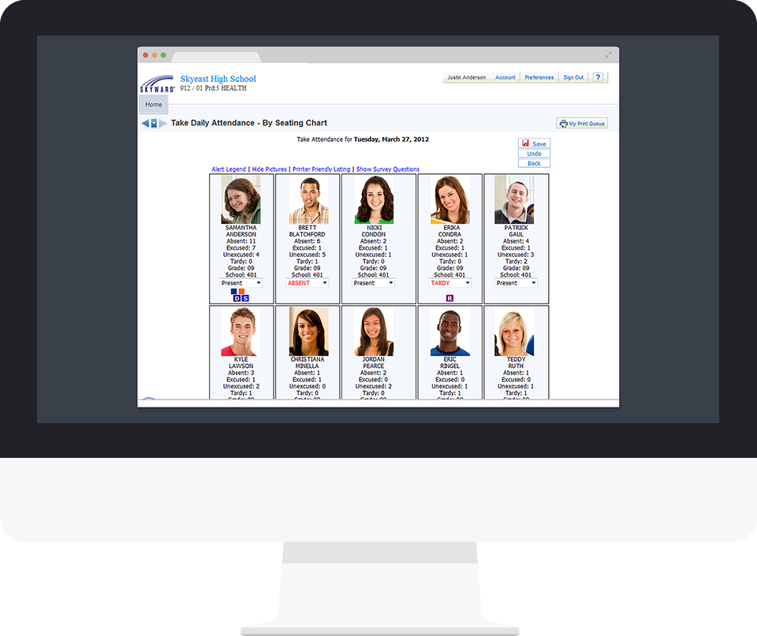

1. KiNVO
   1. <https://kinvolved.com/features>
   2. This product is a mobile and web app that focuses primarily on student attendance and productivity. Through messaging, the system keeps track of student actions and attendance.
   3. The product focuses almost entirely on attendance, and is free for students and teachers.
   4. The app has poor reviews and even recently reset its online reviews on the Apple App Store, which raises suspicion over whether they were trying to delete unattractive history. Additionally, although the app is functional, it does not use any particularly secure forms of identification, such as Biometrics or Bar Codes/RFID.



1. MyAttendanceTracker
   1. <https://www.myattendancetracker.com/>
   2. This product is 100% software, and focuses entirely on attendance. You can message teachers and parents, send reports, and manage attendance closely for a class.
   3. The product is free and is built solely for attendance.
   4. The software is built for a small amount of people, not 2000. It automates the process, but still requires instructor input. It does not integrate with any current attendance database systems. Also, it doesn’t use secure forms of identification, such as Biometrics or Bar Codes/RFID.

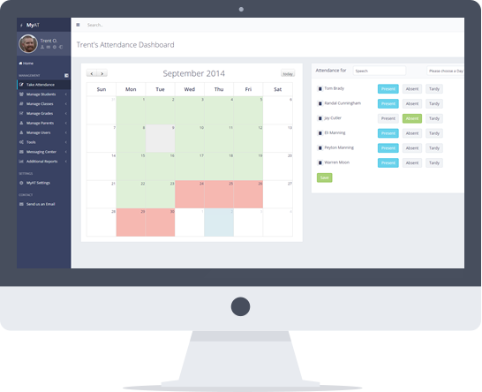

1. JollyTech Scan Station
   1. <http://www.jollytech.com/>
   2. JollyTech sells a product called Scan Station that keeps track of attendance automatically. It logs when a person enters or leaves the building, controls entry guidelines, and creates reports for summarizing general information.
   3. It includes methods such as bar codes, magnetic strips, and proximity chips. It focuses entirely on attendance, and uses advanced methods to do so.
   4. It does not integrate with any current attendance system. Notably, it is not built specifically for students. The software is also expensive and would likely be incredibly overpriced for use with almost 2000 students.

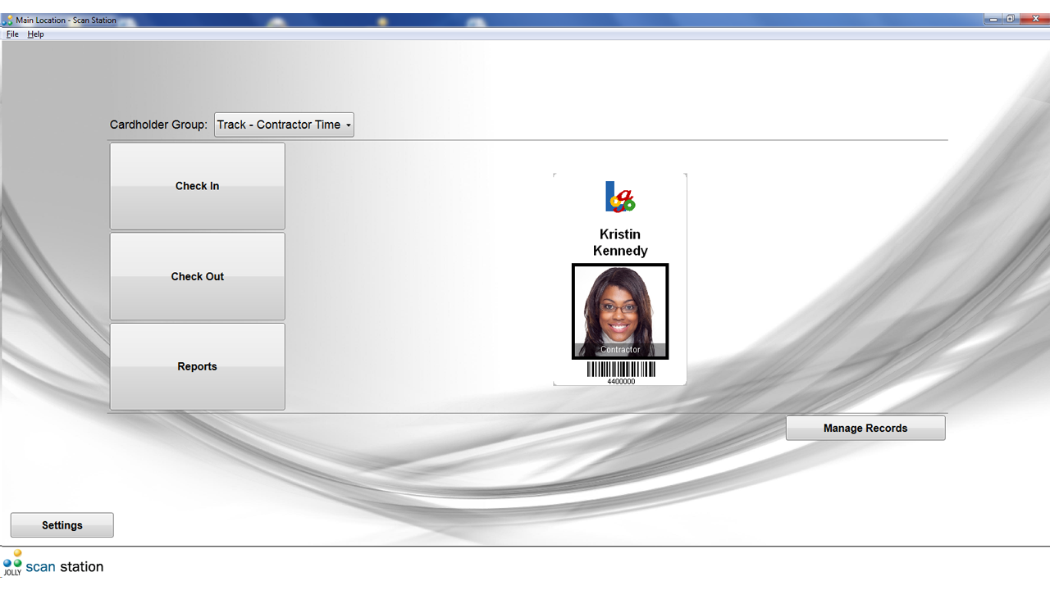

Similar Solutions Matrix

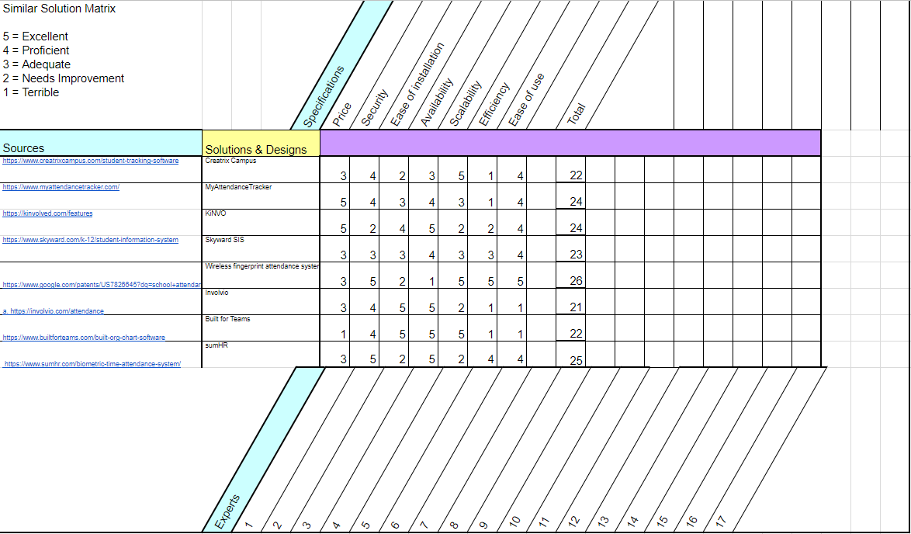

# Element C – Presentation and Justification of Design Requirements

When determining the design specifications and criteria, we looked at each of the similar products and patents that we had researched, and found the things that they either excelled in, or severely lacked. With products, parameters such as cost and availability are obvious criteria that must be met. However, parameters such as security, scalability, and efficiency only became clear to us when we saw that the other solutions had noticeably powerful (or weak) implementations of these criteria. Once we had developed a list of important design specifications, we took the 7 most significant ones for use in future decisions.

Primary Stakeholders

*This list is ordered by highest priority.*

1. **Students**

Second to teachers, students would receive a large benefit from a new system. If they were responsible for signing in and out of class, there would be no discrepancy with false attendance records. Similar to teachers, if the sign in process took no time out of class, then students would lose far less of the already short class time they have. At a school with 8 classes a day such as Woodrow, every minute of the day counts, so a new system that did not take as much time out of the class would greatly benefit students. The current attendance system doesn’t necessarily require their input, they are just negatively affected by the time it takes out of class. Adding some sort of automated system wouldn’t subtract any class time, and would make their records up to them.

<http://www.attendanceworks.org/facts-stats-school-attendance/>

1. **Teachers**

More than any other group, teachers are the primary end user of an attendance system. They are responsible for taking the attendance at the start of every class, as well as backfilling any missed attendance days. Because of this responsibility class time is lost on a daily basis, and after a year can compound to make up a large percentage of total time spent in a class. In a 2017 survey regarding the current attendance system at Woodrow, 68% of teachers agreed that it was a problem, and 100% stated that they would like to see an automated system. If a system was implemented that was completely automated, the teachers wouldn’t lose any class time to roll call and students would be completely responsible for their attendance. Teachers would be the group most benefited by a new product due to their large responsibilities in the current one.

<https://docs.google.com/forms/d/e/1FAIpQLScf6_lSyfIB-q1zBsCkU585ox3RZ_BBkwFxlA-tir-_1EiIig/viewform?usp=sf_link>

1. **Parents**

Currently, the only way for parents to keep up with attendance is through an outdated website called parent portal. Because the parents are most likely the ones that would pay for a student’s truancy dues, it would be very beneficial for them if the student’s attendance record was always accurate. Parents are not necessarily directly affected by this problem, but they do have to deal with the effects it has on their child. If I was a parent, I would want to ensure that my child’s attendance record was as accurate as possible.

<http://m.topix.com/forum/city/greenville-mo/TMC2QA3CJF4KN0TKN>

1. **Administrators:**

School administrators are in charge of maintaining school policies and keeping the school running in general. With kids skipping or leaving class, and with attendance being inefficient, their jobs are made much harder when they have to take care of these issues. With an accurate, efficient attendance system, administrators do not have to stress about managing these issues, and can focus on other priorities.

<http://www.educationworld.com/a_admin/admin/admin263.shtml>

1. **Counselors**

Counselors assist in managing attendance, and are responsible for behavior-management regarding attendance issues. With a more accurate and efficient method of attendance tracking, counselors will have to spend less time managing attendance and can focus their efforts on more important things such as college and class assistance. Also, there will be no false records of kids being absent, so counselors will only have to manage kids that are actually absent and not just falsely accused of it. With counselors being able to commit more time to assisting students that actually need help, their jobs become more important and there will likely be a rise in attendance due to their help.

<http://files.eric.ed.gov/fulltext/EJ1072613.pdf>

1. **Principal**

The principle is responsible for making sure that the school is functioning properly, and ensuring that students are in class is a large part of that responsibility. At Woodrow, students skipping class is a large problem, and if a teacher doesn’t diligently take attendance they may be counted as in class. Similarly, the school gets a certain amount of money per student enrolled, but if this student is truant then the school may not receive that money. Another large part of the principles job is to make sure that the school is improving year to year, and if students are not in class, they cannot increase the rigor of class work. With a more straight forward system, the principle could get more precise data about when students come into class as an automated system could log the exact time they walked in.

<http://www.attendanceworks.org/tools/schools/principals/>

1. **Security Guards**

Security guards, in Woodrow, are in charge of managing students who are tardy or out of class, and giving them tardy slips. This is an inefficient use of time and pay, as security guards should be paying more attention to other safety issues such as unregistered people walking the halls. With this product, the school wouldn’t have to hire as many guards, because tardiness will be automatically taken care of, so we won’t need people looking out in every corner. Security guard over-hiring is an issue, as it takes away from the opportunity to hire teachers and counselors.

<https://www.huffingtonpost.com/entry/school-district-security-guards_us_56faa11ae4b0143a9b4948d0>

1. **Gradespeed**

Because Gradespeed is the current attendance system, a new system would negatively affect them as they would no longer be contracted by the district to run the attendance system. However, because they manage the attendance for every school in the district, implementing this system in Woodrow alone wouldn’t completely eliminate them.

<https://gradespeed.dallasisd.org/gs/>

1. **IT Technicians**

This is the person that will likely be required to install the system and take care of its maintenance. With a highly efficient and simple system, it will make the IT Guy’s job easier. It could be argued that this is a negative effect, because less time hired equals less pay.

<https://www.technologyreview.com/s/515926/how-technology-is-destroying-jobs/>

1. **PTA**

The PTA is an organization consisting of teachers and the parents of students. They organize many of the school events and have influence over school policies. One of the many topics they discuss is attendance, as it affects teachers, and parents deal with the consequences of poor attendance. With a more efficient and accurate system, the PTA will be less stressed towards fixing and maintaining attendance quality, and will be able to put more effort into more positive changes for the school.

<http://www.attendanceworks.org/wordpress/wp-content/uploads/2011/06/School-Attendance-PTA.pdf>

Design Specifications

*This list is ordered by highest priority.*

1. **Efficiency:**

Many current attendance systems require input from both the students and the teachers, and then sometimes require even more input from an administrator that logs the information. Even if you just have to look up and log each student into an app, or have each student separately log themselves in, valuable class time is lost. The product should scan the students as they arrive to the classroom (biometrics, RFID, etc.) and log the information automatically into an accessible database. This would allow classes to start immediately.

1. **Security:**

In order to ensure that the identity of the student is accurate and not being faked, the product needs to use biometrics to log attendance information. Identification cards and RFID are efficient methods, but have loopholes such as “buddy punching,” where someone logs their friend in for them by scanning their cards. With biometrics, it is impossible to log in anyone except yourself.

1. **Cost:**

The solution should be affordable for any school budget, even in schools with thousands of students. The most expensive part of the product is the fingerprint scanner at $50. There is a cheaper option at $30, but it does not allow for 360 degree scanning like its $50 counterpart. Together, our prototype should cost approximately $60, and later products should cost under $50 once we have figured out which materials are best and cheapest to use. We plan on selling our product for the manufacturing price, so these predictions are likely to be accurate in the future.

1. **Scalability:**

Many schools have thousands of students and are constantly growing, so the software that tracks their attendance must easily be able to support those large numbers and growths. Many current solutions are too focused on small groups, causing large groups to become too expensive, or are too focused on single classrooms, not allowing for integration into a larger, entire school system. The product must be able to handle potentially infinite (to a reasonable amount) students, and be able to connect every class’s attendance into a larger, complete database.

1. **Availability:**

In addition the product needing to be completed and deliverable, there needs to be adequate marketing and support so that customers are aware of the product and are easily able to make arrangements to purchase/use it. Many current solutions have vague information on the status of their product and do not have an efficient method of customer support, leading to issues with attempting to purchase them. Additionally, many patents have highly detailed descriptions of their product, but often have no clear follow-through or way to view the actual product.

1. **Ease of Use:**

The product needs to be understandable and simple, and the user interface must be clean and easy to look at. Many current solutions are overcomplicated and have outdated designs, causing consumers to turn away from them.

1. **Ease of Installation:**

The product needs to be easy to install for multiple reasons. It provides incentive to use the product, and the less time spent, the less money spent. If expertise is required to install the product, that is an additional and unwanted cost. Also, if installation is simple, it goes without saying that repairs will likely be simple too, extending the life of the product.

Expert Analysis and Feedback

**Sharon Lane Hughes**

DISD Attendance Improvement and Truancy Reduction – Coordinator

Email: [SLHughes@dallasisd.org](mailto:SLHughes@dallasisd.org)

Phone: 214-932-5368

Ms. Hughes responded to us with a positive opinion of our project, along with a large list of points that concern what we have attempted and what we might want to attempt. Although we want to use biometrics, Ms. Hughes suggested that, “monitoring the time it takes for 25 individuals to ‘thumb in’ may be helpful as you develop you plan,” because she had worked similarly with ID cards and time still became a barrier for her. Additionally, she pointed out that we need to pay attention to legal and privacy issues that may create obstacles down the line. As the coordinator of attendance improvement in DISD, Ms. Hughes has been heavily involved in research regarding attendance, and understands the issues and opportunities behind our goal. The ideas that Ms. Hughes presented clearly have a lot of experience behind them, and will be very helpful in improving our project proposal and moving forwards with our product.

**Mary Lara**

DISD Attendance Improvement and Truancy Reduction – Administrative Assistant

Email: [MLara@dallasisd.org](mailto:MLara@dallasisd.org)

Phone: 214-932-5356

We attempted to contact Ms. Lara, but she has not responded since. As an administrative assistant for attendance, she understands how to manage attendance in schools, and she knows what works and what doesn’t. In the area she works, they have discussed many methods of attendance tracking and have gone over the pros and cons of each one. They know how to test new methods, and they know the laws and legalities concerning what we are trying to accomplish. Ms. Lara’s expertise is highly valuable to us, as she is a leader in the field we are trying to make a change in.

**Matt Schneider**

Field CTO

Dell EMC | Enterprise Pre-Sales

Email: [matt.schneider@dell.com](mailto:matt.schneider@dell.com)

Phone: 972.325.8126

Matt is the Chief Technology Officer at EMC, the biggest Computer data storage company in the world. He has had years of experience with data bases and understands how massive metadata architectures work. After speaking with him about my work towards an automated attendance system, he brought to my attention some alternative methods of student tracking such as facial recognition. Facial recognition is becoming more popular and in his words “the lack of touching provides for a safer environment and the faster it gets the easier is it to do things like unlock doors as your approaching.” He does agree that biometrics are a promising area to look into, as they offer more than just attendance tracking. Although he did show me some systems that implement biometrics, he said that “Roll your own facial recognition is becoming pretty common… you can simply consume an Amazon API (MS has similar) to do matching.” The facial recognition software is already out there, so creating an attendance product comes down to the hardware and software that integrates it. Because this software just uses traditional cameras, it could double as a security cameras system.

**Sally Salinas**

Attendance Improvement Specialist

Adamson, Bryan Adams, Wilson, Skyline, Conrad

Email: [arsalinas@dallasisd.org](mailto:arsalinas@dallasisd.org)

Phone: 214-932-5301

Sally is the attendance specialist for Woodrow Wilson, as well as 5 other schools in DISD. She knows the specifics of attendance at Woodrow, and therefore could offer some insight into the inner workings of the current attendance system. I was unable to get a response from her, so I cannot offer any input from her. Here is the email I sent her:

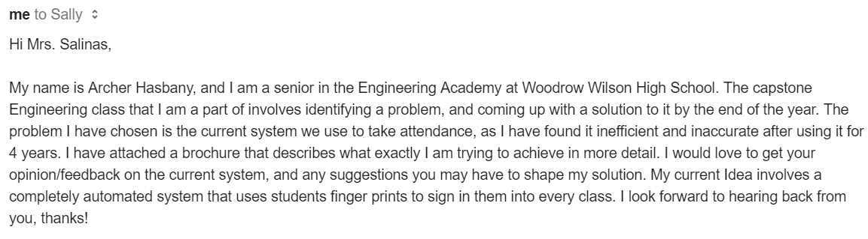

# Element D – Design Concepts Generation, Analysis, and Selection

Summary

Part D is the stage of this class when we decide on the initial solution we want to develop. We began with a class wide brainstorming day, in which we all came up with ideas for each other’s problems. The white board below was ours, and from that you can see how our next phase of ideas developed. Both of us came up with two solutions that we thought were viable, and made PowerPoint slides to justify that. After adding those 4 to our researched solutions matrix, we decided that fingerprint scanning would be the most effective. The mockup of the scanner itself can be seen on the last page of the document.

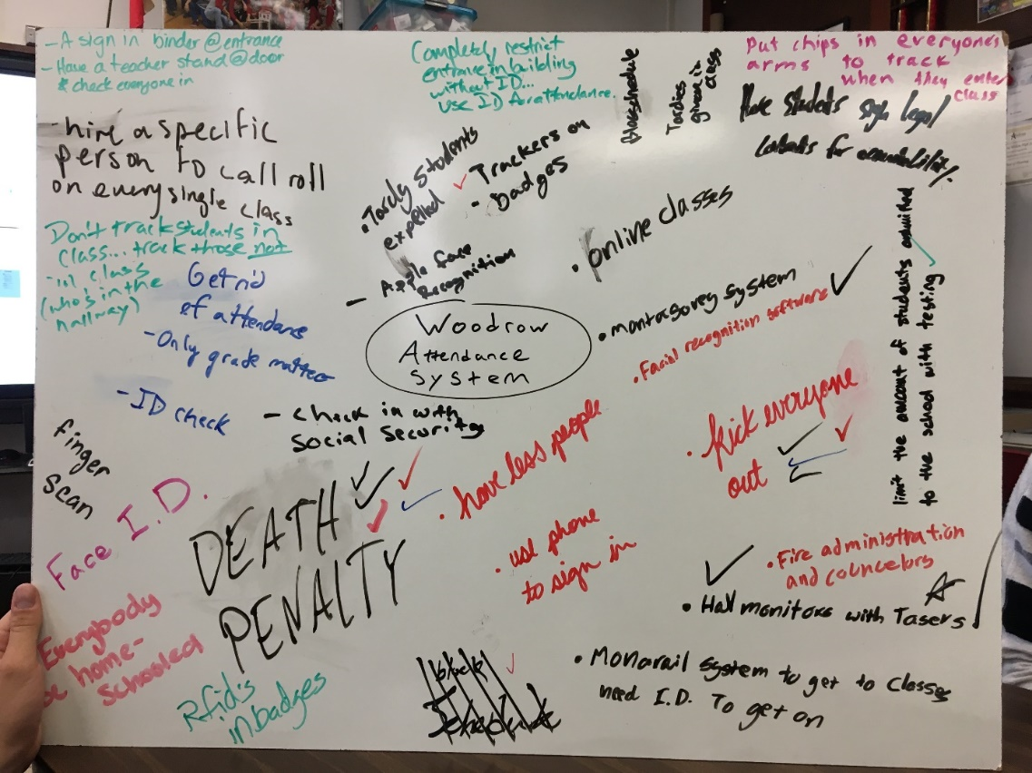Brainstorming

While most of these solutions do solve the problem, they rely on methods that are unrealistic for Woodrow. Most recommendations utilize technology, which will almost certainly be an aspect of the best solution. Trackers on badges/ID’s would work assuming that every student always has their ID on them, as well as never giving it to another person to falsely log them in. Using phones to sign in would be restricted by students without smart phones, and would not solve the issue of low efficiency, as it would take a long time. Similar to that, solutions that add another staff member to the school or offload the current task do not save us any time or resources. The death penalty would be ultimately effective in removing tardy students, but is likely beyond our current limitations.

Concept Development

The following PowerPoint slides are the 4 ideas that we thought were the best solutions to the problem.

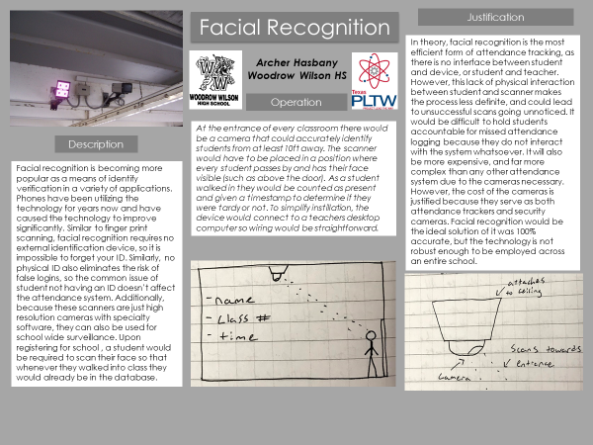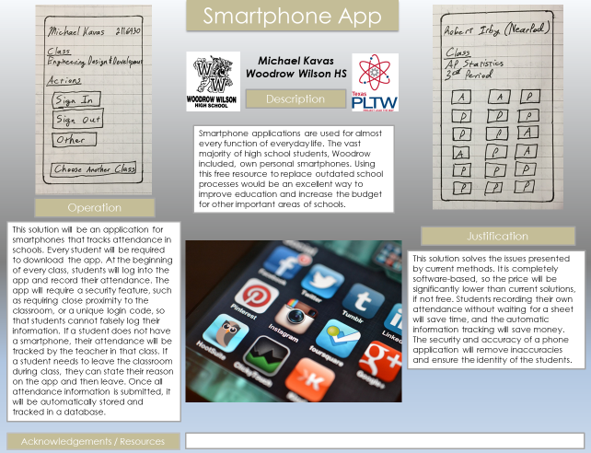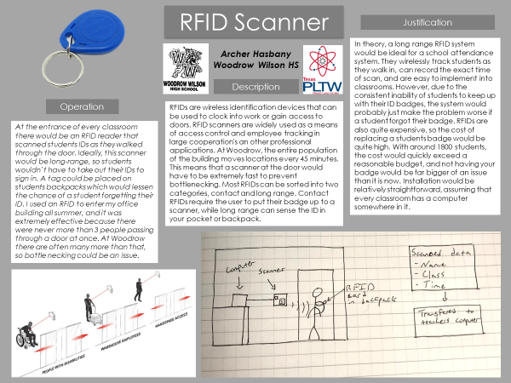

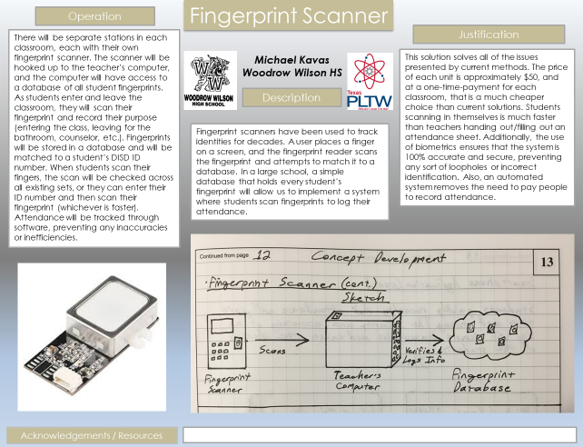

Solution Matrix

The solution matrix is a tool used to compare possible solutions to a problem in an unbiased way. We used this as an opportunity to truly see if the fingerprint scanner was the best theoretical solution. The solution we envisioned not only ranked higher than other ideas we came up with, but was also higher than all previous attempts that we researched.

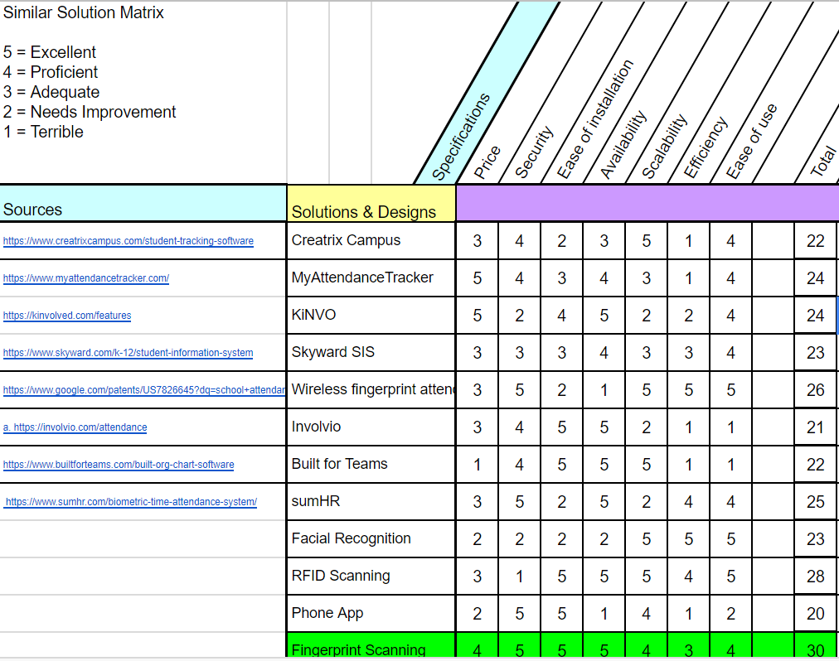

As shown in the solution matrix above, we have decided to move forward with the fingerprint scanner as it is extremely efficient and secure. We have already developed a prototype and plan to begin working on software in the next few weeks. They are very straight forward to set up and allow for easy scaling to organizations of any size. We believe that using a fingerprint scanner is the most feasible technique for tracking attendance.

Mock Up

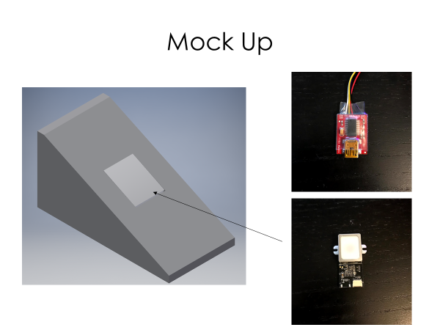

FTDI Serial Adapter

3D Printed Case

Fingerprint Scanner

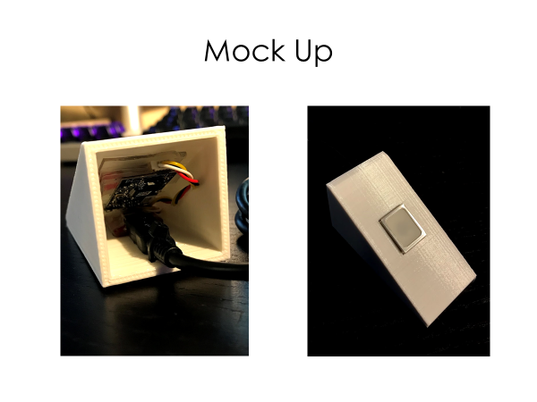

Top of Case

Back Side of Case

# Element E – Application of STEM Principles and Practices

Technical Sketches

Scanner case

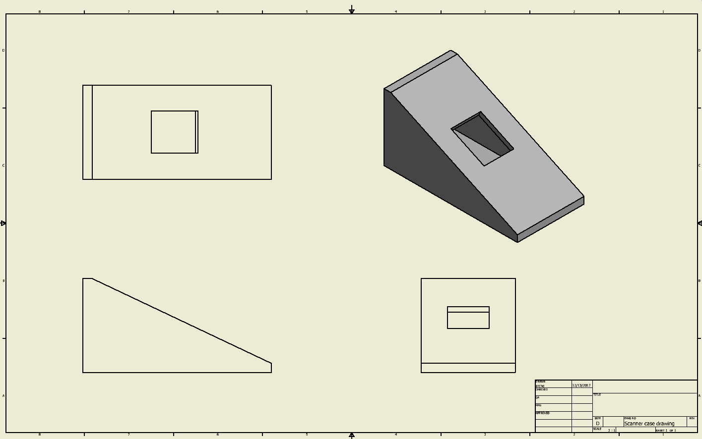

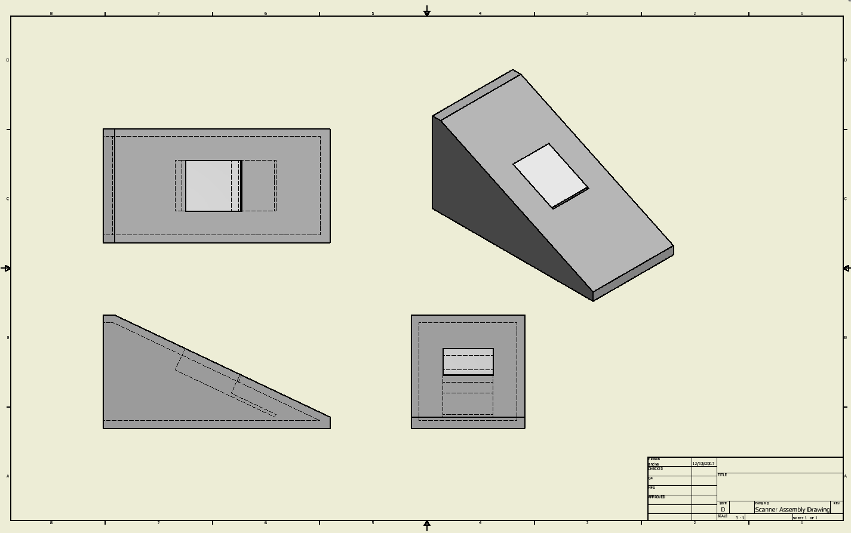Scanner Case with Scanner

Scanner case

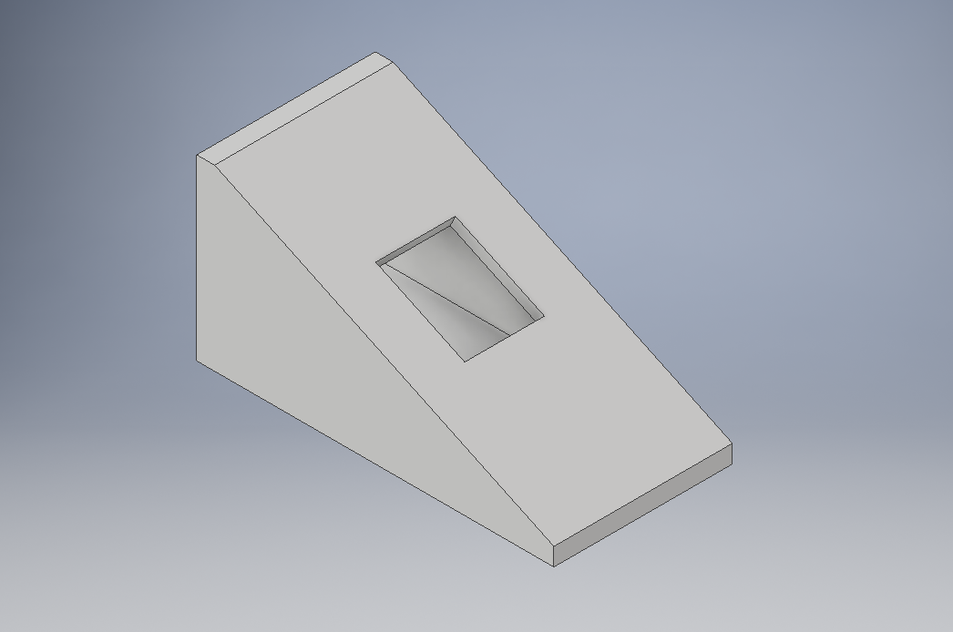

CAD of Case

Scanner

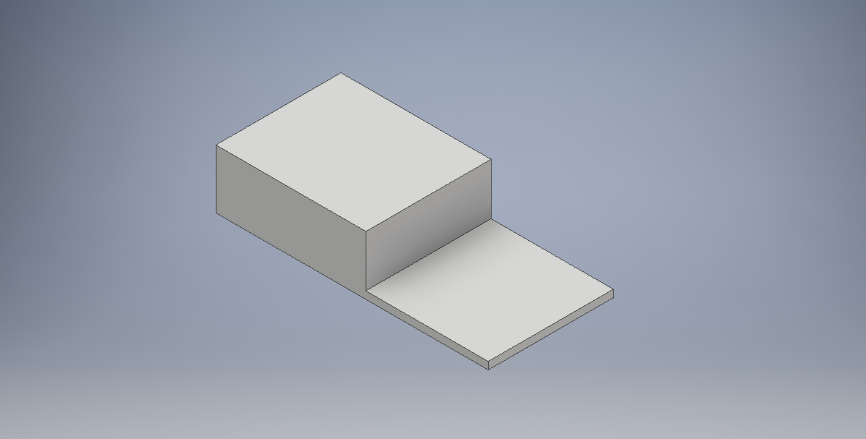

CAD of Fingerprint Scanner

Analysis of Needed Tools, Materials, Methods, and Knowledge

Tools:

* 3D Printer
  + For initial prototyping, I am using my personal 3D printer to make the housing for the electronics. This allows for extremely rapid prototyping and testing.
* Arduino IDE
  + The Arduino IDE is the software we use to address the fingerprint scanner, it is crucial for being able to scan your fingerprint in multiple locations.
* Computer
  + The computer is used for all 3D modeling and programming.

The use of a 3D printer and Arduino IDE allow us to rapidly prototype the scanner and make changes without any 3rd party fabrication methods. We can reprint the case with our home or school 3D printer, and programming is easy to do from any computer.

Materials:

* PLA spool - Material used in 3D printer
* Fingerprint Scanner
* FTDI Serial Adapter - Bridge between computer and fingerprint scanner
* Mini USB Cable

Methods:

* 3D printing
* Autodesk Inventor
* Programming in C

Knowledge:

* Arduino
* Autodesk
* Database Integration

Quantitative and Qualitative Analysis

Quantitative

* Price
  + $30-50 per unit
* Security
  + 100% scanner accuracy
* Ease of Installation
  + Entire campus could be set up in a day
* Availability
  + 100 of each electronic component readily available
* Scalability
  + Scalable to 100+ classrooms
* Efficiency
  + Less than 2 seconds to sign in
* Ease of use
  + No training required

Qualitative

* Price
  + Reasonable for District/school budget - Because the school has a certain budget for technology, our solution would have to be attractive enough to them to make them want to fit it into the budget. School would need to approve the cost of 100+ units.
* Security
  + No ability to buddy-punch - We aim to see no false attendance records due to proxy sign ins for at least a year.
* Ease of Installation
  + Teacher could install if necessary - If given to all teachers, none would have an issue setting the unit up.
* Availability
  + Could source enough of the electronics needed - This is not as applicable to our solution as it was to the researched solutions in early phases, however, we would need to source at least 100 of each part to furnish the entire school.
* Scalability
  + Could be used for any size of a building - Adding a unit to a school network would be straightforward, with no limit to number of units.
* Efficiency
  + Does not take any class time away - We will send out another poll to the teachers we ask to test to see if it does indeed save class time.
* Ease of use
  + Basic software installation - Teachers could easily find and download the software from the software portal on their computers.

# Element F – Consideration of Design Viability

Similar Product Lifecycle

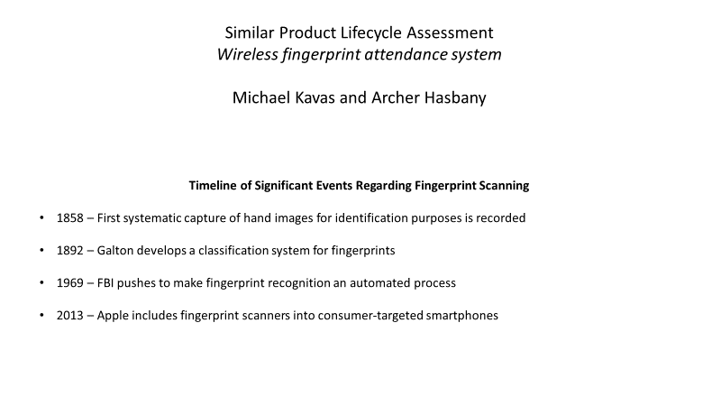

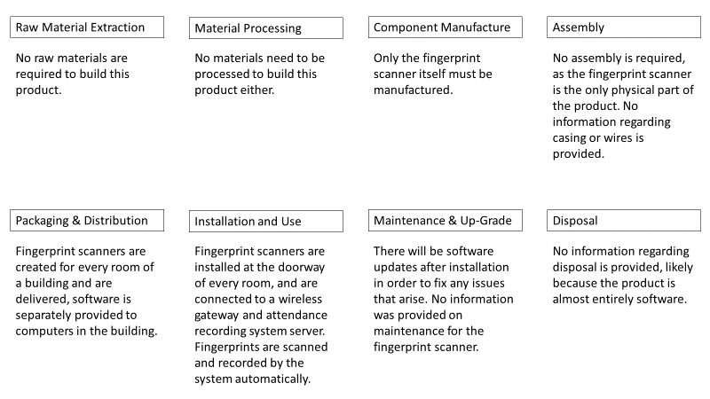

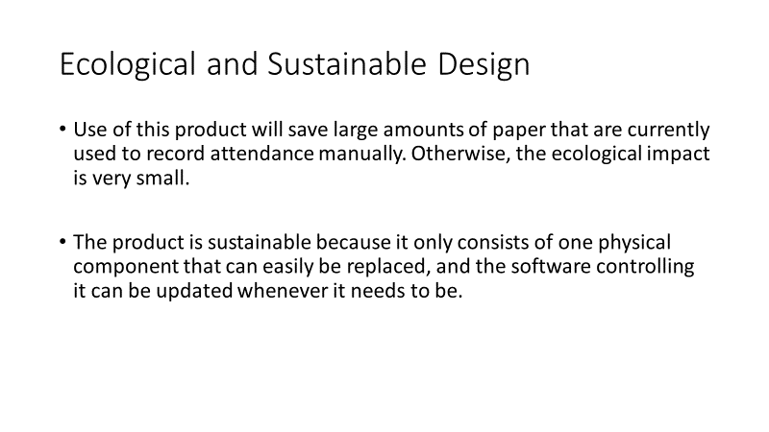

Materials List

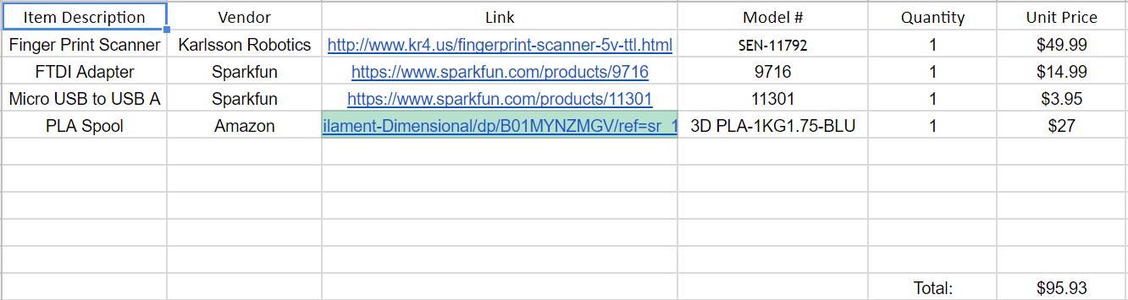

Solution’s Lifecycle Assessment

**Timeline of Significant Events Regarding Fingerprint Scanning**

* 1858 – First systematic capture of hand images for identification purposes is recorded
* 1892 – Galton develops a classification system for fingerprints
* 1969 – FBI pushes to make fingerprint recognition an automated process
* 2013 – Apple includes fingerprint scanners into consumer-targeted smartphones

**Raw Material Extraction**

No raw materials are required to build this product.

**Material Processing**

No materials need to be processed to build this product either.

**Component Manufacture**

The fingerprint scanners are bought wholesale, and their casing will be 3D printed.

**Assembly**

Assembly involves placing the fingerprint scanner inside of its casing, and inserting the wires required for connection.

**Packaging & Distribution**

Fingerprint scanning systems are created for every room of a building and are delivered, software is separately provided to computers in the building.

Brochure

The brochure is used to promote our product and give a full summary our project to possible stakeholders.

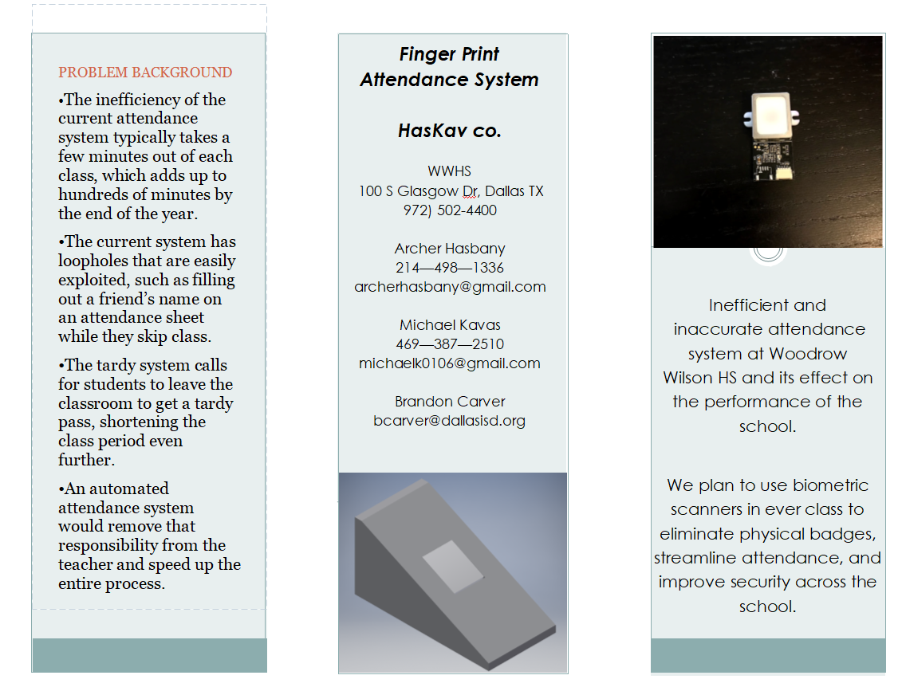

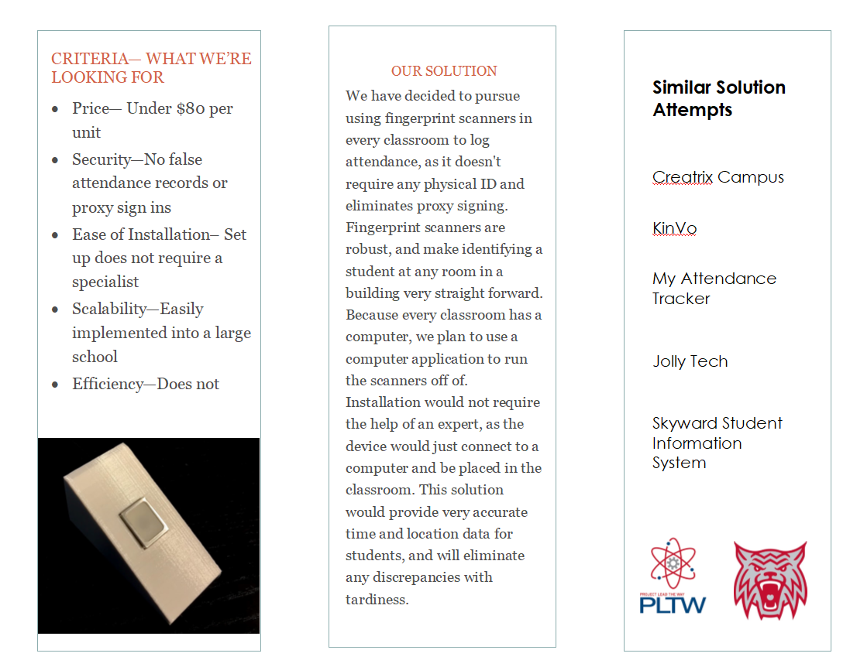

Fundraising Plan

Needed Resources:

* $50 - Fingerprint Scanner
* $15 - 5V FTDI Serial Adapter
* $4 - USB cable
* $0 - Programming Software
* $27 - Spool of PLA plastic for 3d Printer

Tools required:

* Soldering Iron - Already Owned
* 3D printer - Already Owned

Knowledge Required:

* Soldering Skills
* 3D Modeling (AutoDesk Inventor)
* Programming in C
* DIY Electronics
* Total Initial Cost = $96
* Cost per unit: $68
* What we hope to raise: $500

Fundraising Plan:

Because the initial price only includes the parts needed for one unit, we have had no trouble affording the parts with savings from our summer jobs. However, as we expand this project and begin building more units for testing, we will have to rebuy the components that make up the actual scanner.

1. GoFundMe - GoFundMe would most likely serve as an easy outlet for our family members and friends to donate to us.
2. Pay for initial units with savings - This has been sufficient for our initial purchases, but as we expand to more than 1 unit, the price will exceed our savings.
3. Make a pitch to the District - Because this has the potential to save them a lot of money, we plan to present them the idea with a working prototype.

# Element G – Creation of a Testable Prototype

Build Process

1. Solder FPS to the FTDI adapter
2. Download and install drivers for the demo software
3. Download and install demo software
4. CAD a custom case to hold both the FPS and FTDI adapter
5. Assemble parts into the case and zip tie USB cable to case

Mockups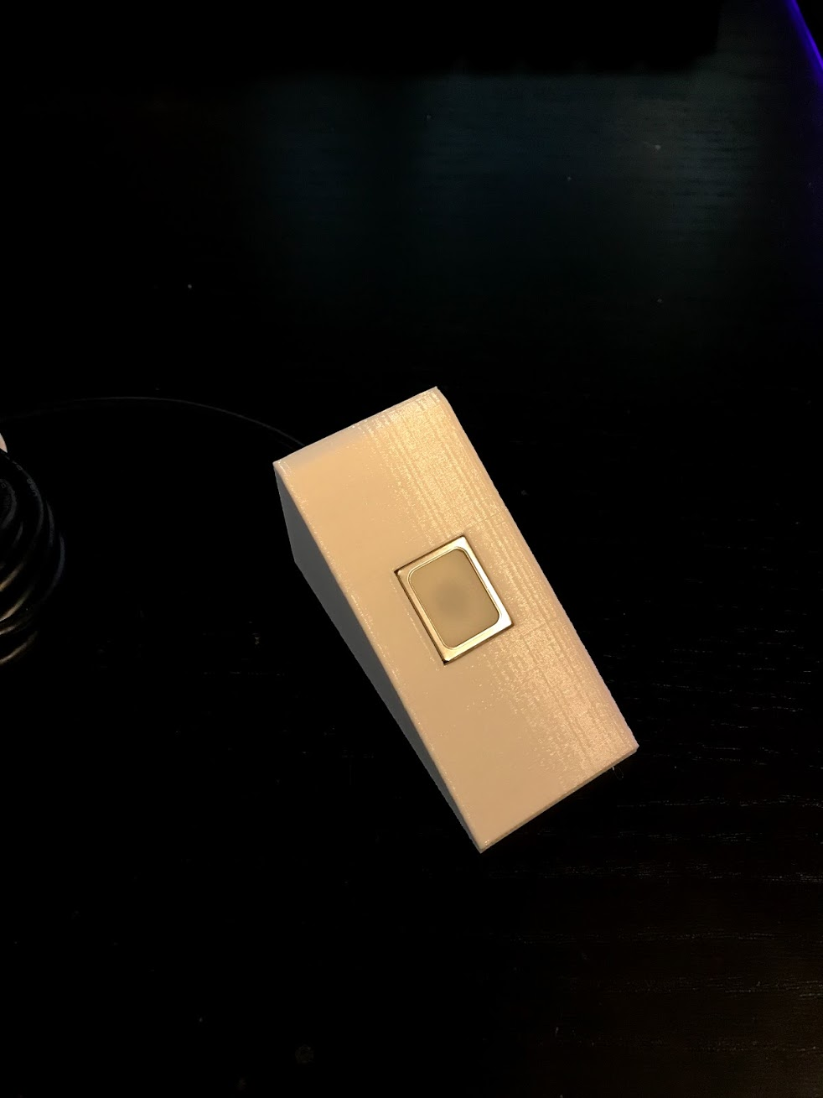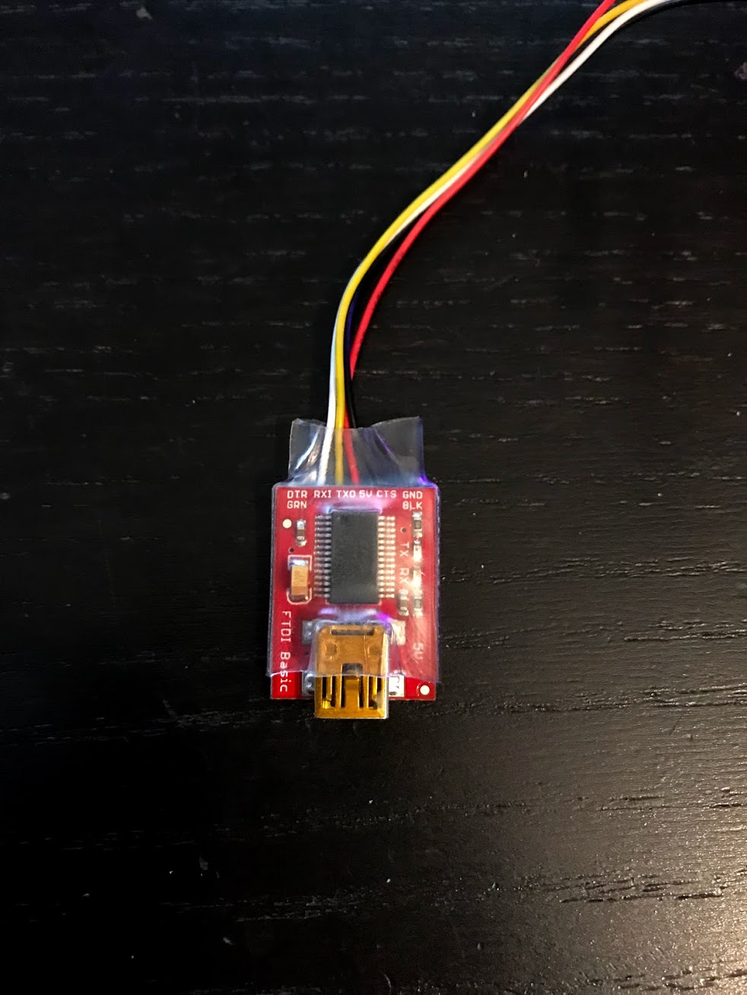

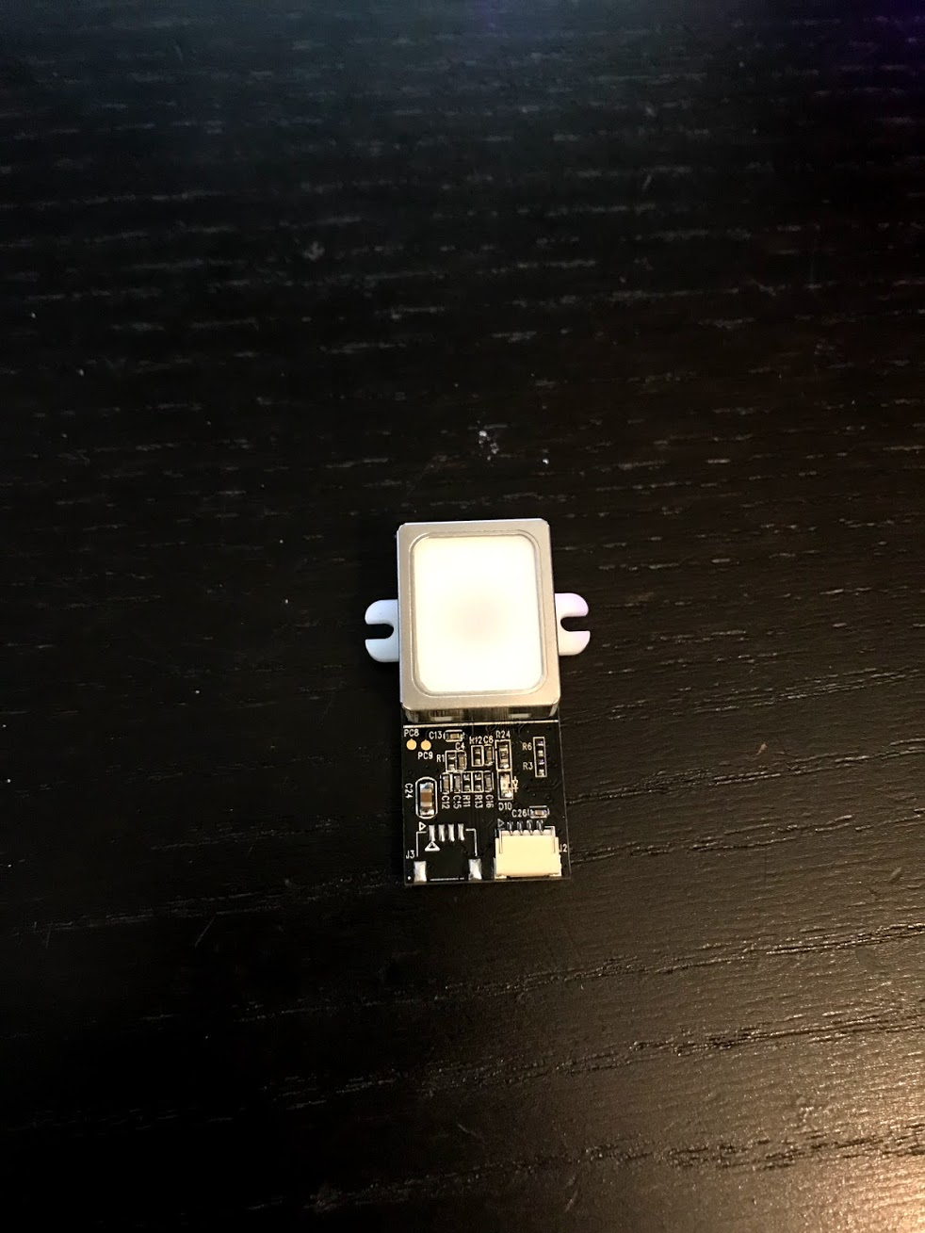

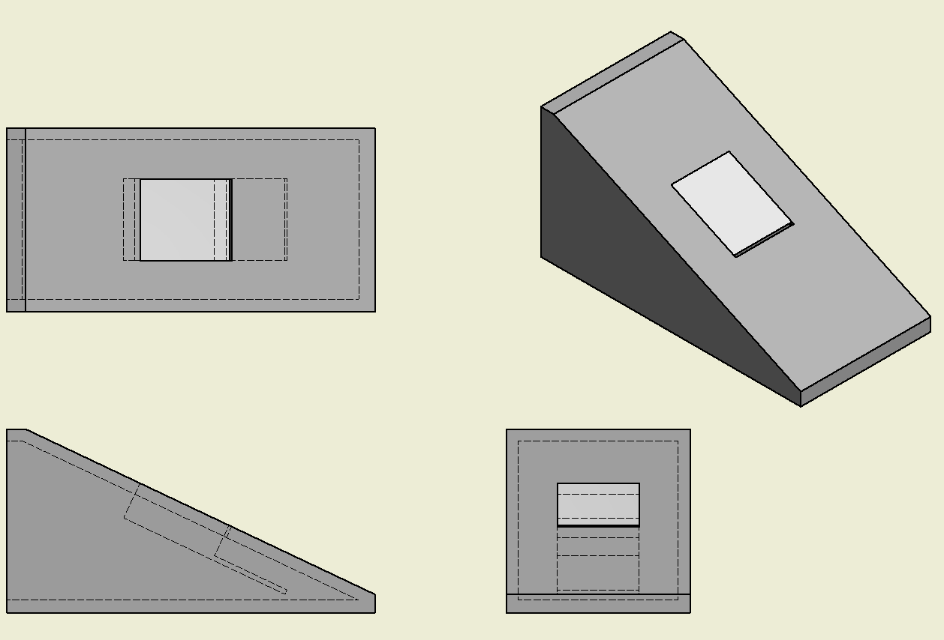



Testing

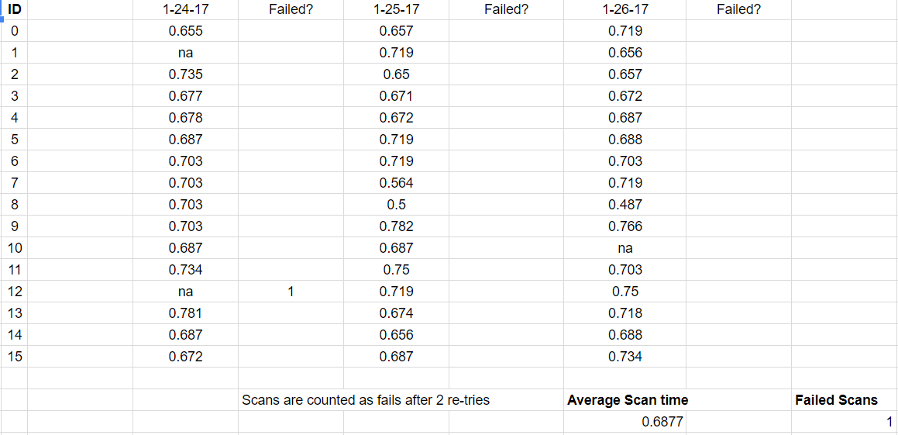

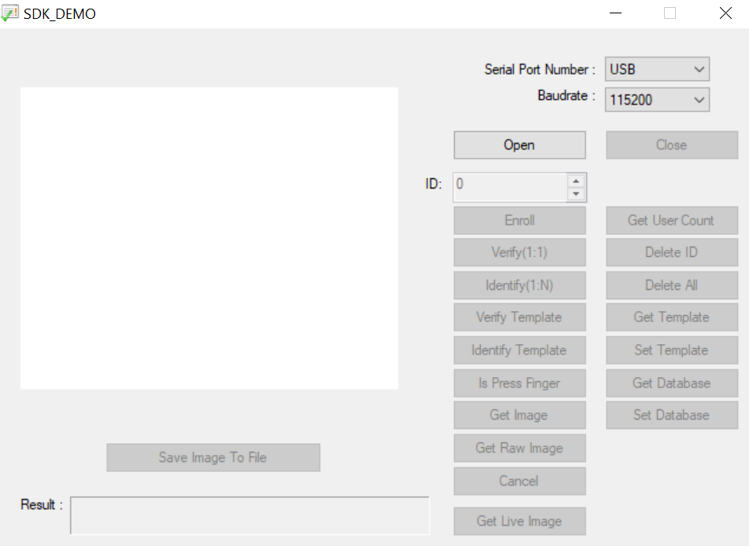

Testing Process:

To determine how robust the fingerprint scanner is, we used the demo software to take attendance in class for 3 days. We determined that the scan time was extremely fast, and reliable. As long as the person places their finger square on the scanner and removes it when it says so, they could easily scan into class in les that a few seconds. We quantified a failed scan as two or more failures to recognize a fingerprint, and only occured on across the days of testing.

Modifications During Build

Due to our information session at UTD, we have decided to change to an Arduino as our means of communication with the FPS. If we had continued with the FTDI adapter, we would have had to learn C, which would most likely have taken the rest of the year. The arduino utilizes a simple programming environment, so we can focus less on how we program it, and more on what we program it to do. Due to this change, the connection to the FPS is little different, and requires 3 10k ohm resistors to drop the voltage down to the right level for serial communication. We are still working out how the scanner interacts with the Arduino, but we have code ready to run and begin gathering fingerprints. The Arduino is substantially larger than the FTDI adapter, so we have redone the CAD for the case and updated the needed parts list. Below, both the new wiring layout and programs are shown.

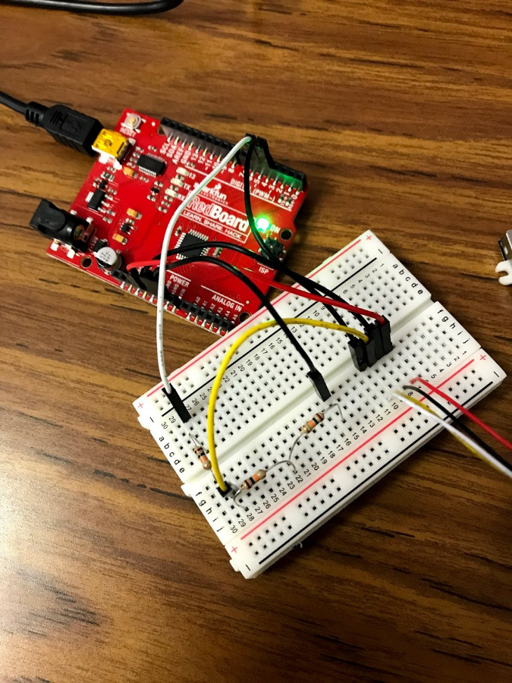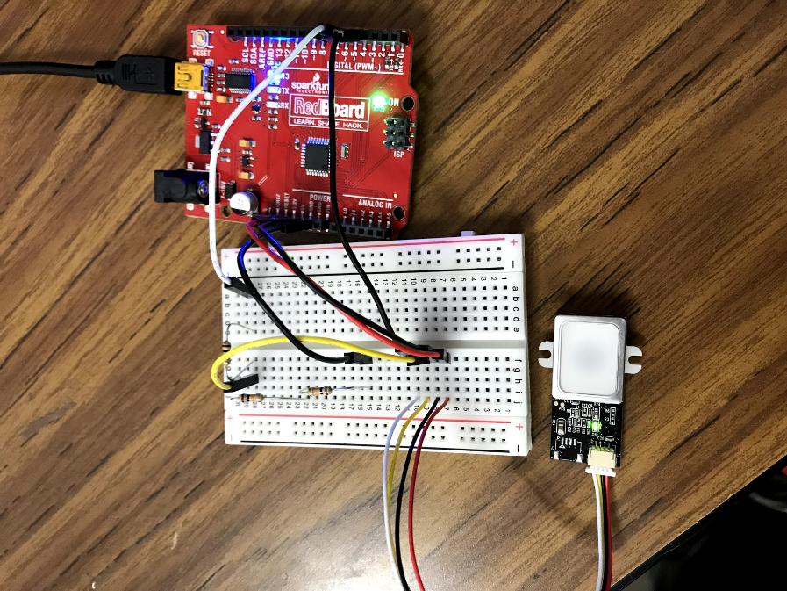Final Prototype

Arduino connected to the breadboard



CAD for Larger Case

# Element H – Prototype Testing and Data Collection Plan

What is our criteria for testing?

To determine whether our prototype is feasible on both a physical and software level, we are going to run tests on increasingly large groups of students at our school. Because this system will have to keep track of hundreds of fingerprints a day, we must ensure that the scanner is robust and fast. Our criteria details a product that is efficient in a large school environment.

* Speed:
  + Scan time less than 2 seconds
* Efficiency:
  + Does not bottleneck the entrance of a class
* Accuracy:
  + No more than 1 re-scan per class period
* Reliability:
  + Can run the entire day without downtime

Where are we going to test it?

The testing will primarily take place at woodrow, as it is the target environment for our product, as is directly accessible to us on a daily basis. Our first testing cycle was completed in our EDD class to determine whether the scanner itself was robust enough for our project. As we develop our own software and improve our prototype we will expand to the robotics team, and then multiple classrooms.

When will this testing take place?

We tested in our EDD class from 1/24 to 1/26. More testing will occur once we have improved our prototype, and will likely occur during a school day or before a robotics meeting.

Who will we be testing on?

We began our testing on the students in our EDD class. Once we have developed a more usable and efficient prototype, we plan to test on our school robotics team members, and then expand to multiple classrooms at Woodrow.

Initial Testing Instructions

1. Connect the fingerprint scanner to a computer and open the demo software
2. Make sure the correct COM port is selected and open the connection
3. Enroll each student under an ID and record it on a spreadsheet
4. On the following days, record how long it took each student to scan into class



# Element I – Data Results and Testing Analysis

**Prototype’s Design:**

Currently, our prototype consists of the arduino and fingerprint scanner connected through a breadboard, with no protecting case. We plan to use a smaller arduino in our next design, given that we don’t require all of the features of the model we’re currently using. Additionally, we will 3D print a case for the entire system to go into so that it is protected and contained.

**Testing Procedures:**

Our testing involved our prototypes hardware and software. It initially consisted of recording every person's fingerprint and then asking them to scan their finger as they came into class. We did this for 3 days and recorded the time it took for each finger to scan and how many times the scan failed. This ensured that our hardware was reliable and efficient. Once we had software for placing our data into a spreadsheet, we tested reading our fingerprints into an excel spreadsheet. This is an essential part of our product, as we have to populate a database to track attendance. To improve our testing procedure, we have to improve our software first. Once we can have everyone sign in and have the product reliably record attendance information into a spreadsheet with all the data we need, we can actually test our product to see if it solves the problem as intended.

*Our first testing procedure: signing in every student and recording time/failure rate*

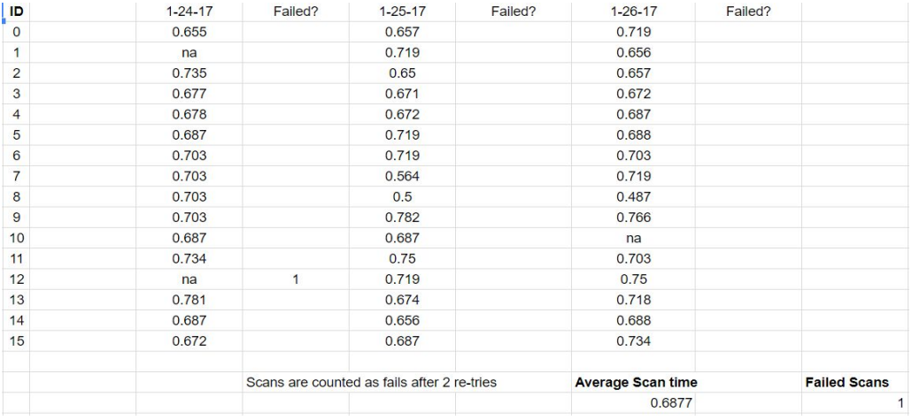

*Our most recent testing procedure: signing in every student and recording the time per person*

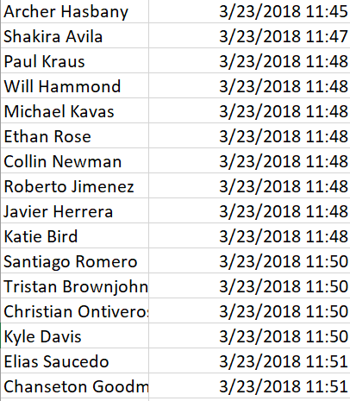

**Data Collected:**

The fingerprint scanner reads fingerprints in less than 1 second consistently, and only failed once out of over 30 times. Additionally, the excel file accurately creates a timestamp for each separate scan. We plan on testing the ability to separate times into class periods, and to create a database that is usable for DISD attendance information.

Conclusions

1. A design solution to a technical problem is an iterative process because the product continues to be tested and improved. Once the prototype has been created, it has to be tested. Once it has been tested, it has to be improved. This process iterates until the product is complete.
2. Evaluating our testing results is important because it allows us to ensure that our product is adequately solving our problem, and to see areas where we need to most improve our product.

# Element J – Documentation of External Evaluation

By: Chanston Goodman

Element A, B & C

I thought the background of the problem was justified in an extremely good fashion and proved that the attendance system at Woodrow Wilson is ineffective. Being a student from Woodrow I definitely agree with this problem needing to be solved because I have also been accused of being absent when there’s substitute teachers taken the roll for classes and according to the survey given out to teachers 65% of them did as well. This old fashion way of taken attendance has long been outdated and I’m glad someone is trying to make a change. I found your Element B to be done well because you not only found similar solutions but you also highlighted things that were positive about the product, but also picked it apart and told why this similar solution does not fully solve the problem. This is an important aspect of the problem because it proves that your problem still hasn't been fixed to the best of its ability. I was also pleased by your Element C and how you listed who would benefit from a new attendance system. This also shows how not implementing a new system would continue to affect those same people. In conclusion your Elements A - C were spot on and proved each topic you were trying to achieve.

Element D, E, F & G

I thought the class brainstorming in Element D was very useful and from the lookings of it so do you guys. Even though some of the ideas where over the top I liked how you explained why some of them where unrealistic instead of just saying that they wouldn't work, and the solutions you believed could have a shot at solving the problem of poor attendance at Woodrow where placed in an matrix, which ultimately helped you choose your solution to the problem, a fingerprint scanner. Your Elements E & F in my opinion were done perfectly because they display what your prototype looks like and how it should function. Also listing out carefully everything needed in order to make your solution exist and solve the problem of Woodrow’s attendance. Your element G lists out everything you need to build your device so that if you were to hand this over to someone they’ll know exactly how to make this device the way you guys did. In conclusion your Elements D - G walk us through how you came up with a solution and how your solution should function/work and I believe that you guys did an effective job at displaying your solution to the problem.

Element H & I

The one thing I liked and would like to point out on your element H is not only did you list what you were testing for but you gave the reason for testing and what a successful test would look like for example, a scan lasting less than two seconds would be a success. This strategy makes your testing of the protype simple and easy because you know what you're looking for and if it doesn't meet your testing requirements you can make the adjustments necessary to your product.

By: Ethan Rose

1. Problem background is detailed and well-explained, gets point across that the attendance and tardy system is inefficient. For the problem statement, I don’t think it should be included that the attendance system is inaccurate unless it was part of the survey or explained in the problem background.
2. Explain more on why the similar solutions would not work at Woodrow. What makes them insecure? Aren’t corporations larger than Woodrow? Formatting of the matrix could be improved, hard to read on the document. Otherwise the rest is fine and all solutions are relevant.
3. Mary Lara should not be included in the *Expert Analysis and Feedback* section if she never gave any feedback. What is said about Ms. Lara is true of Ms. Hughes too and could be included there instead. This applies similarly to Mrs. Salinas. Stakeholders and design specifications all directly apply, no changes needed there.
4. The pictures of the slides for *Concept Development* are nice but are too small to read. It would be helpful to include a few tidbits about each concept after the pictures that would justify their ranking in the decision matrix. Always assume that the reader has never heard of these ideas before. The matrix itself is much easier to read than the previous one and better formatted.
5. *Technical Sketches* are great, no issue there. They give a good idea of what the final product will closely resemble. Analysis of needed methods, tools, etc. is fine, no change needed. *Qualitative and Quantitative Analysis* could use more explanation for each criterion.
6. *Similar Product Lifecycle* should include examples of products that addressed attendance at schools, not the history of fingerprint scanning. Lifecycle of product is not addressed, should include description of durability of product and how often it will need to be fixed. Brochure is very clean and gets the point across nicely. No change needed for *Fundraising Plan*.
7. Explanation of the software shown in the graphics should be included, reader might not be able to tell what it does. Everything else is good.
8. Testing on the robotics team members and other classrooms should be included if it was done. The “Why” for testing is missing from this element. Otherwise looks good, the testing instructions are easy to follow.
9. Few complaints here, the data for testing is present and a concise explanation is provided for the procedure and why the information gathered is relevant. However, the Speed, Efficiency, Accuracy, and Reliability testing criteria were not explicitly addressed, nor all included. The paragraph before the conclusions does mention the speed being below 1 second and that the Excel file creates an accurate timestamp, but the other two criteria are not present.

# Element K – Designer Reflection on the Process

Michael Kavas

Element A:

Our justification had plenty of responses and clearly showed that our project would be valuable. The similar solutions were very close to our intended product but all had unacceptable cons (to our standards). When working on this, I should have created a more in-depth survey and reached out to more people (teachers).

Element B:

The similar patents and solutions were all similar to our project, but we did not look into them more than what they offered. Next time, I would find out where the patents went/what they became, and try to extract useful information from them rather than simply finding them and writing about them. Our similar solutions matrix did show what products to focus on as far as looking for ideas went, but was overall slightly arbitrary and should have included more mathematically created results.

Element C:

Some of our primary stakeholders were affected very heavily by our problem. However, the others were affected much less and probably should have been replaced by groups of people more involved with our problem. All of our design criteria were very important to the development of our project and were followed fairly heavily when designing our product. Our expert feedback failed in that we didn’t get responses from everyone, but we succeeded in that our responses were insightful and provided views and opinions that we would not have considered.

Element D:

Our brainstorming was only partially serious and did not result in many truly considerable ideas. However, our concept development was very successful. All of our 4 ideas were highly possible and considerable, and we ended up going with one of them, the fingerprint scanner. Through the use of the final similar solution matrix, we made our final choice to follow through with the fingerprint scanner. However, the matrix was again slightly arbitrary, and since we favored the fingerprint scanner before creating the matrix, it was slightly biased.

Element E:

Our mockups and technical sketches were exactly what they needed to be at the current stage of our project. However, it would have been better if they also included sample code, but we were not at that point yet. Our needed tools and methods were outdated because of our later switch to using an Arduino, but it was accurate at the time. The quantitative and qualitative analysis consisted of some guesses and hopeful goals, but they were absolutely things that we hoped to achieve with our final product.

Element F:

Our product life cycles were very similar, likely because the two products are very similar. They were simple and short, because the product is made from simple 3D printed parts and parts that have already been made. The brochure was updated to reflect our product more accurately. We should have shortened the pages into more readable, understandable sentences. Our fundraising plan was short, because our project was cheap to create and did not require much funding. However, any funding is useful and it would have been smarter to put more effort towards raising some money.

Element G:

Our build process was accurately explained and our final prototype was portrayed. The testing was useful and was a good example of what our current product could accomplish.

Element H:

Our criteria and who/when/where information adequately explained each category and showed what we planned to do with our testing process. I wouldn’t change anything about it. The testing instructions were accurate but simple, so I would go a little more in depth with them so that they would be easily repeatable.

Element I:

The explanation of our prototype’s design should have more detail, but it explains the basics decently. The testing procedures are explained in detail, and the included tables show the information we gathered. Overall, the explanation of our prototype and our testing was enough but should have more depth.

Archer Hasbany

Over the course of the year, we have learned a lot about the values of following a specific design process in order to best accomplish our goals. While every element has a lot of room for improvement, the entire document as a whole is a starting point for this projects eventual progression into a real product.

Element A:

The problem background is well substantiated and comes from a clearly personal standpoint. The initial poll was good information, but more data similar to it could help make the point that the problem is affecting a broader scope than just Woodrow. The attack path diagram is accurate, but after completing my prototype, the diagram needs another path focused on the innerworkings of a school. While the legal and economic issues come as a result of this project, the real benefit is efficiency within the school. The relevant associations are well explained and relate directly to the problem being solved.

Element B:

The patent research shows that there aren’t any other solutions out there that address the problem that we set out to solve, and the ones that come close were entirely theoretical. This documentation was some of our most thorough and demonstrated the clear need for a solution. None of the existing products came close to what we wanted, and the similar solution matrix shows that.

Element C:

The stakeholders are almost entirely within the school, and now that the product exists we have come to realize that it can be used in a large variety of applications other than a school. Our design specifications have stayed true throughout the year and do a good job of outlining what we hoped to do with our project. Our expert feedback was extremely helpful but reaching out to them multiple times in the year would have added a lot to the project.

Element D:

Element D is one of the most important elements of the year, and I feel that we did not put as much time into the early brainstorming as we should have. We had already purchase a fingerprint scanner when we started element D, so a lot of the brainstorming wasn’t done as thoroughly as it could have been. We spent a large amount of time on our solutions matrix to ensure that it was not biased to one type of solution, and although a fingerprint scanner was one of our original ideas, it came out as the best option regardless. The mock up was well done, and actually functioned as a sign in device and it served as a great starting point for the rest of the year.

Element E:

The technical sketches were simple but represented the solution well. There really aren’t many physical parts as the code is where most of this project was developed. While we overshot our price goal our other measurable qualitative and quantitative goals were successfully met.

Element F:

Element F did not add much to our project, as most of our development went into code, which has no physical lifecycle. Our brochure summed our goals very clearly and served as a great starting point for our conversations at Verizon. We didn’t actually do any fundraising, as most resources were affordable with our own budget,

Element G:  
 While our build process was accurate for the mockup, it has changed dramatically since then. Our testing gave us a good estimate of scan-in time, which turned out to be far below our hope. This renewed our confidence for this scanner specifically as a solution to our problem.

Element H:

The testing we conducted went well and showed that we were very close to the product we set out to make. The actual process needs more explanation and isn’t perfectly indicative of the procedure we took. There are a lot of technical details that we left out which are critical to the function of our prototype.

Element I:

The testing in element I was our best part of the project, it was simply the protype working exactly as we designed it to. All I had to do was open up an excel spreadsheet and plug in the scanner, and then I just watched everyone sign in. The scanner didn’t fail, and there was no bottleneck at the door. This moved our project forward by a large margin, and has given us clear next steps for the project.

# Element L – Presentation of the Designer’s Recommendations

Components:

1. [Sparkfun Pro Micro – 3.3V/8MHz](https://www.sparkfun.com/products/12587)
2. [Fingerprint Scanner - TTL (GT-521F52)](https://www.sparkfun.com/products/14585)
3. [USB Micro-B Cable](https://www.amazon.com/s/ref=nb_sb_noss_1?url=search-alias%3Daps&field-keywords=micro+usb+cable)
4. [USB Mini-B Cable](https://www.amazon.com/s/ref=nb_sb_noss_1?url=search-alias%3Daps&field-keywords=mini+usb+cable)
5. [JST SH 1.0-4 Pin](https://www.amazon.com/Micro-4-Pin-Connector-100mm-Female/dp/B01DUC1M2O/ref=sr_1_4?ie=UTF8&qid=1523066210&sr=8-4&keywords=JST+SH+1.0-4+Pin)
6. [Qwiic Cable](https://www.sparkfun.com/products/14425)
7. [FTDI Basic Breakout – 3.3V](https://www.sparkfun.com/products/9873?_ga=2.225618842.1605265513.1523065827-1356206490.1505362462)

Software Needed:

The Arduino sketch and other necessary software for this project can be found [here](https://drive.google.com/drive/folders/11oa_-r4eMONUwEJseBHirg0Kcr1Ss1Sm?usp=sharing), but I have chosen to leave out the Arduino IDE in the folder as there are regular version updates. Download the latest version [here](https://www.arduino.cc/en/Main/Software).

Hardware Hookup:

1. Solder JST cable to the Arduino:
   1. TX (white cable) to pin 8 of Arduino
   2. RX (yellow cable) to pin 7 of Arduino
   3. GND (black cable) to GND pin of Arduino
   4. Vin (red cable) to VCC of Arduino

Wiring Diagram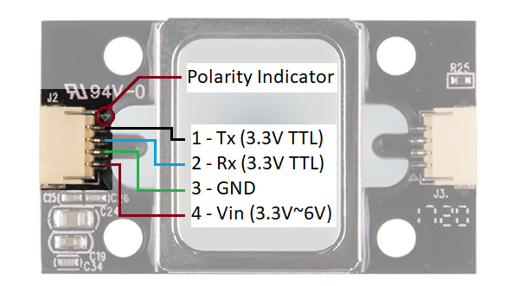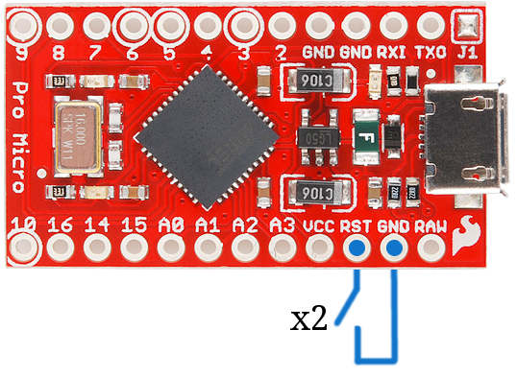

1. Connect Qwicc Cable to FTDI Adapter
   1. TX (pin 1) to RX of FTDI Adapter
   2. RX (pin 2) to TX of FTDI Adapter
   3. GND (pin 3) to GND of FTDI Adapter
   4. Vin (pin 4) to 3.3v of FTDI Adapter

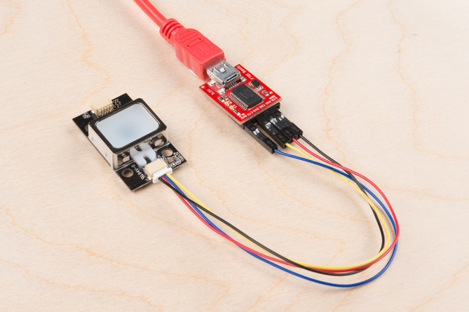Wiring Diagram

Enrolling into the FPS:

1. Plug the FPS into the FTDI adapter
2. Unzip the folder called “Enrolling Software”
3. Go to the directory that it was unzipped into, which should look similar to this: …\20171129-SDK Demo Ver1.9\Release .
4. Open the SDK_DEMO.exe executable.
5. Select the COM port that the FTDI enumerated to in the Serial Port Number’s drop-down menu
6. Select 9600 in the Baudrate’s drop down menu.
7. Click on the Open button.
8. Choose an unused ID number and click enroll
9. 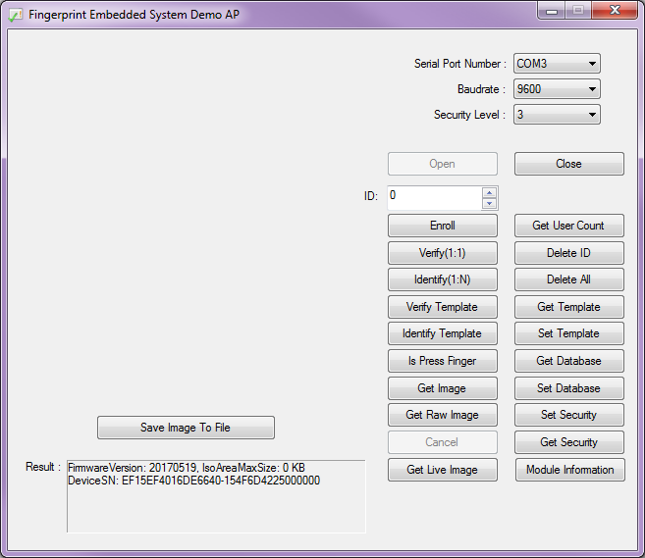Once you are finished enrolling, plug the scanner back into the Arduino.

**6**

**7**

**8**

**5**

Programming the Arduino:

1. Download and install the latest [Arduino IDE](https://www.arduino.cc/en/Main/Software)
2. Sparkfun has a great guide on setting up this particular Arduino, follow the “Installing: Windows” tutorial [here](https://learn.sparkfun.com/tutorials/pro-micro--fio-v3-hookup-guide#installing-windows). Follow the steps and then return back to this guide.
3. In the folder you downloaded at the beginning, find the “Fingerprint Scanner” folder and open the Arduino sketch called “FPS Project”
4. Download the Fingerprint scanner library [here](https://github.com/sparkfun/Fingerprint_Scanner-TTL), this does all of the behind the scenes communication with the fingerprint scanner.
   1. Once downloaded, go to the Arduino IDE and click “Include Library” under the “Sketch tab”
   2. Select “Add .zip Library” and choose the library folder that you downloaded. (Note, if the library fails to install try unzipping the downloaded folder and then select that.

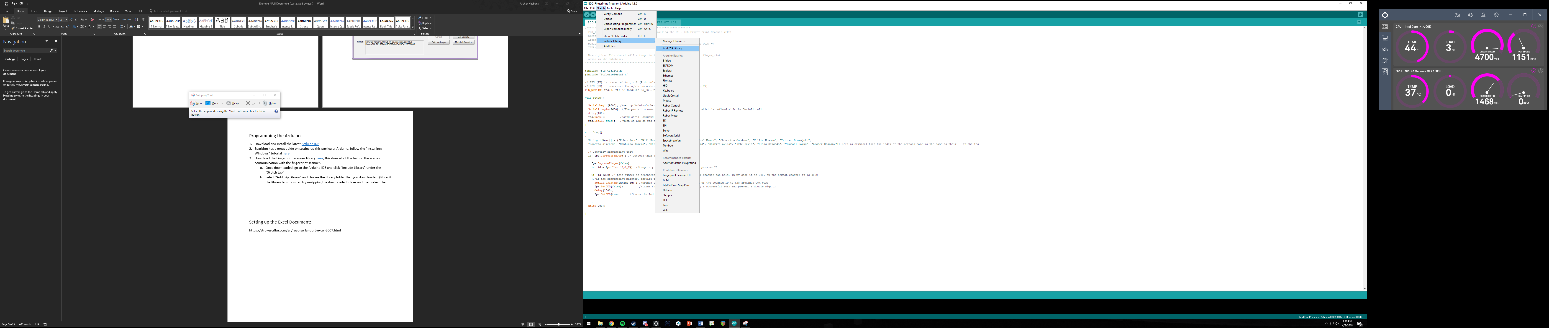

1. Under the “Tools” tab, find and select the “SparkFun Pro Micro” under the “Boards” tab.

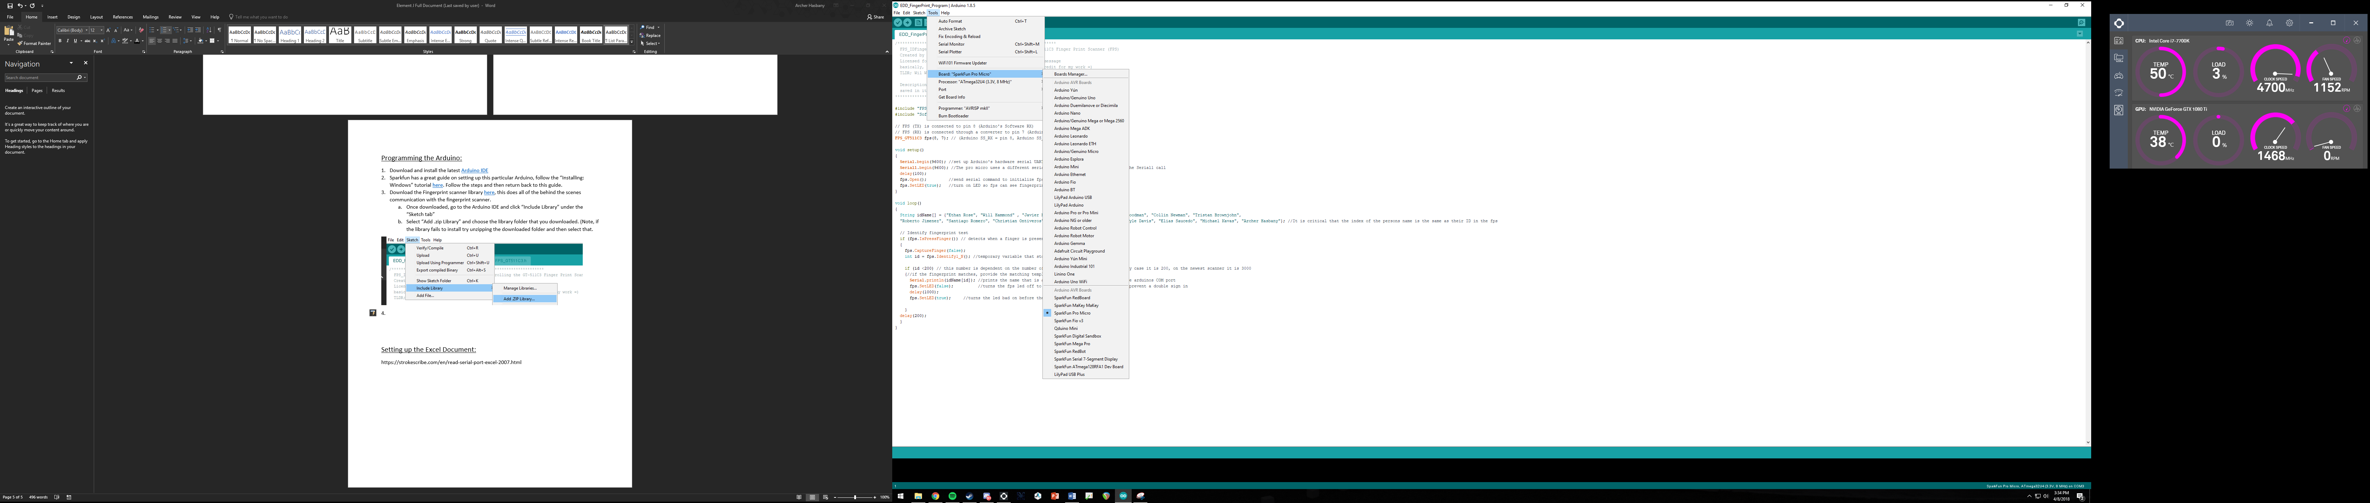

1. Under the Tools tab, make sure you’ve selected the correct COM port under the “Port” tab. You can determine what port the Arduino is on in your device manager in the Ports dropdown.
2. Now its time to upload the sketch to the Arduino. Click the arrow under the edit button and the sketch will compile and upload to the board.

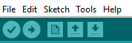

Setting up the Excel Document:

1. There is a great tutorial on Stroke Scribes website for getting the application set up in an excel document. Follow it [here](https://strokescribe.com/en/read-serial-port-excel-2007.html) and then proceed with step 2.
2. In the same place you pasted the code from their website, place the following code under it in the Visual Basic editor window.
3. Plug in the Arduino and make sure the current port is selected in the properties of the “COM” object.

Private Sub Worksheet_Change(ByVal Target As Excel.Range)

If Target.Column = 1 Then

t = Now()

ThisRow = Target.Row

Cells(ThisRow, 2) = t

End If

End Sub

# Final Notes

This project was born out of me and another students frustration with the attendance system at our high school, and over the course of the last 7 months we have come up with a product that is a step in the right direction for improving it. All skills necessary for this project were learned over the course of the year, including using Arduinos, serial data transmission, Excel VBA scripts, and custom circuitry. While the final prototype is relatively simple in both assembly and programming, countless hours of research and trail and error preceded it. Hopefully this guide will serve as a good starting point for further development on this idea, and feel free to email us at [archerhasbany@gmail.com](mailto:archerhasbany@gmail.com) or [michaelk0106@gmail.com](mailto:michaelk0106@gmail.com) with any questions or suggestions.